Help us spread the word on social media about the new, easy voting options available to voters in 15 California counties thanks to the Voter’s Choice Act. This toolkit is for Los Angeles County only. Access the general VCA Toolkit at voterschoice.org/tools-for-organizers

Join our social media storms every Wednesday, January 15 - March 3 using #LAVotes and #MoreDaysMoreWays.

Los Angeles voters have more days and ways to cast their ballots in 2020 thanks to the Voter’s Choice Act and Voting Solutions for All People. Under the new law voters can return their ballots by mail, at a ballot drop box, or they can vote in-person at any vote center in their county, starting 10 days before Election Day and through Election Day, including weekends.

Our research shows the following best practices for social media posts:
- Mention Los Angeles County @LACountyRRCC in your post. Not all counties are implementing a new voting model. We don’t want to confuse voters so be specific and list Los Angeles County.
- Tag your friends and partners to increase interactions. Feel free to tag us @VotersChoiceCA and we will retweet your post.
- Direct voters to a website to get more information. For LA you can use lavote.net
- Use #LAVotes and #MoreDaysMoreWays to be part of the Twitter storm.

Thank you to our partners
the League of Women Voters of California and
the Voter’s Choice California Steering Committee
for their contributions to this resource.
This Social Media Toolkit is created for Twitter, but the postings and images may be used for Facebook and Instagram. Use #late votes and #MoreDaysMoreWays to be part of the Twitter storm at 10am on Wednesdays starting January 15.

Wednesday, January 15: E-48
The Presidential Primary is less than two months away. Voters in @LACountyRRCC have #MoreDaysMoreWays to vote. Are you ready to vote? #LAVotes www.sos.ca.gov/elections/cavoter

Not registered with a political party? You will be mailed a nonpartisan ballot, which will not list presidential candidates, unless you contact your county elections office lavote.net #LAVotes

Wednesday, January 22: E-41, State and County Voter Information Guides mailings begin on Jan 23
Voters in @LACountyRRCC have #MoreDaysMoreWays to vote. Your party registration matters when voting for President. Learn the special rules for the Presidential Primary. www.sos.ca.gov/elections/voting-info/how-vote-president

Voters in @LACountyRRCC will receive election materials in the mail. Is your address current? Check your voter registration status today www.sos.ca.gov/elections/cavoter Voters in @LACountyRRCC have #MoreDaysMoreWays to vote. #LAVotes

Wednesday, January 29: E-34, Vote by Mail ballots are on their way
Keep an eye on your mailbox. All voters in @LACountyRRCC will receive election info in the mail. Voters in @LACountyRRCC have #MoreDaysMoreWays to vote. Learn more at lavote.net #LAVotes

Check your mailbox. Voter information guides and election materials are on their way! Every registered voter in @LACountyRRCC will receive election info in the mail. Learn more at lavote.net #LAVotes #MoreDaysMoreWays

Wednesday, February 5: E-27, Ballot drop boxes are available throughout the county starting E-29, Feb 3
Get ready to vote. Update your registration by February 18 to get all election materials by mail. www.sos.ca.gov/elections/cavoter #LAVotes

Are you voting by mail in LA? Return your ballot at any drop box in @LACountyRRCC or by mail. No postage needed. Don’t forget to sign your envelope! lavote.net #LAVotes #MoreDaysMoreWays

Wednesday, February 12: E-20, Valentines Day Feb 14, Registration deadline for administrative purposes closes on Feb 18
We LOVE to VOTE! And now @LACountyRRCC voters have #MoreDaysMoreWays. Vote in-person starting Feb. 22. Learn more at lavote.net. Use the locator tool to find your nearest vote center https://locator.lavote.net/locations/vc #LAVotes

We LOVE Voting! Update or register by Feb. 18 to be mailed your election materials. If you miss the date; @LACountyRRCC voters may visit any vote center starting Feb. 22 to register and vote in-person. Learn more at lavote.net #MoreDaysMoreWays #LAVotes

Wednesday, February 19: E-13, Vote centers open Saturday Feb 22
Not registered to vote? Voters in @LACountyRRCC can register and vote at any vote center starting Sat Feb 22. Yes, you can vote on a Saturday! lavote.net #LAVotes #MoreDaysMoreWays

Everyday is Election Day Feb 22 through March 3! Voters in @LACountyRRCC have #MoreDaysMoreWays. Find out more lavote.net #LAVotes

Wednesday, February 26: E-6, all vote centers open countywide Feb 29-March 3,
@LACountyRRCC voters can vote today! Visit any vote center starting Feb 22 through March 3 lavote.net #MoreDaysMoreWays

Vote early and avoid the lines! Voters in @LACountyRRCC can visit any vote center starting Feb 22. And even vote on the weekend. Find out where lavote.net #LAVotes #MoreDaysMoreWays

Daily Tweets Friday, February 28 to Tuesday, March 3

Friday, Feb 28
Vote early and skip the line! Drop off your ballot or vote in-person at any vote center in @LACountyRRCC this weekend. Learn more lavote.net #LAVotes #MoreDaysMoreWays

You can still register and vote at any vote center in @LACountyRRCC. Go today and through March 3. Learn more lavote.net #LAVotes #MoreDaysMoreWays

Saturday, Feb 29
Avoid the lines on Election Day and vote today! Visit any vote center in @LACountyRRCC or drop off your ballot at a ballot drop box (no postage needed). Learn where lavote.net #LAVotes #MoreDaysMoreWays

Celebrate Leap Day and Vote! Vote at ANY vote center in @LACountyRRCC today. Learn where to go lavote.net #LAVotes #MoreDaysMoreWays

Sunday, March 1
Skip the lines and vote today! All vote centers are open and you can vote at any location in @LACountyRRCC. Learn where lavote.net #LAVotes #MoreDaysMoreWays

It’s Sunday! Get your weekly To-Do List started and Vote today! Visit any vote center in @LACountyRRCC. Vote today, Don’t delay. Learn where lavote.net #LAVotes #MoreDaysMoreWays

Monday, March 2
Didn’t register to vote? It’s not too late. Register and vote at any vote center in @LACountyRRCC. Learn where lavote.net #LAVotes #MoreDaysMoreWays

Avoid the lines tomorrow and vote today! Don’t wait. Visit any vote center in @LACountyRRCC or drop off your ballot. Learn where lavote.net #LAVotes #MoreDaysMoreWays

Tuesday, March 3 - Election Day!

It’s Election Day! Bring your BFF, your parents, siblings, partners, co-workers, dog, cat -ok not your dog or your cat - but any other eligible voter and visit any vote center in @LACountyRRCC to register and vote the same day. lavote.net #LAVotes #MoreDaysMoreWays

Not registered to vote? No problem. Visit any vote center in @LACountyRRCC to register and vote the same day. lavote.net #LAVotes #MoreDaysMoreWays

Last day to vote! Have your voice heard. Visit any vote center in @LACountyRRCC to register and vote the same day. lavote.net #LAVotes #MoreDaysMoreWays

It’s Election Day! Still have a mail ballot? Drop it off at any vote center in @LACountyRRCC. Learn where lavote.net #LAVotes #MoreDaysMoreWays

Go vote! You can still register and vote today. Visit any vote center in @LACountyRRCC Learn where lavote.net #LAVotes #MoreDaysMoreWays

It’s Election Day! Lost your ballot? Visit any vote center in @LACountyRRCC to vote. Learn where lavote.net #LAVotes #MoreDaysMoreWays

It’s Election Day! Want to vote? It’s not too late. Visit any vote center in @LACountyRRCC to register and vote the same day. Learn where to go lavote.net #LAVotes #MoreDaysMoreWays

Using social Media Graphics in Posts
Use graphics to attract attention to your post. Save the images on your computer as a .png or .gif by hitting right click on the image and selecting “save as picture.”
Make images more accessible. Instructions for how to add descriptions and enhance accessibility on social media platforms are available in this accessible social media tutorial.
Feel free to use any of the images in this toolkit. They were developed from public free stock images.

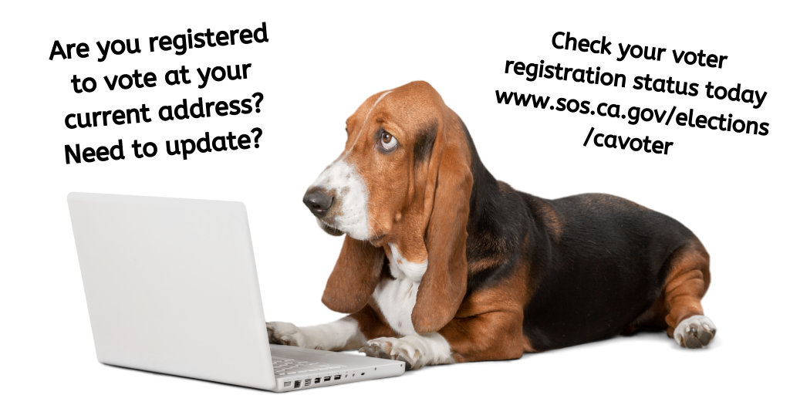

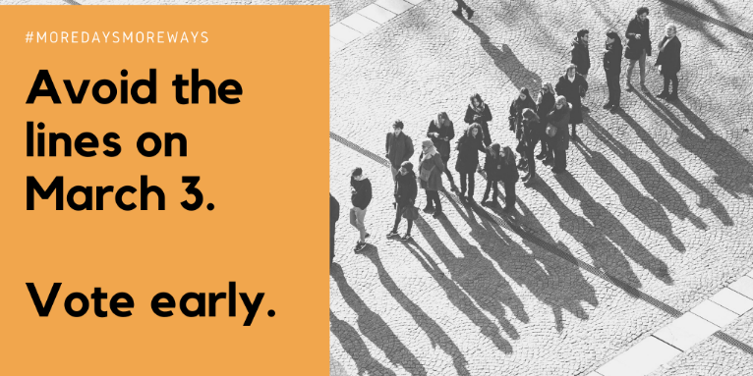

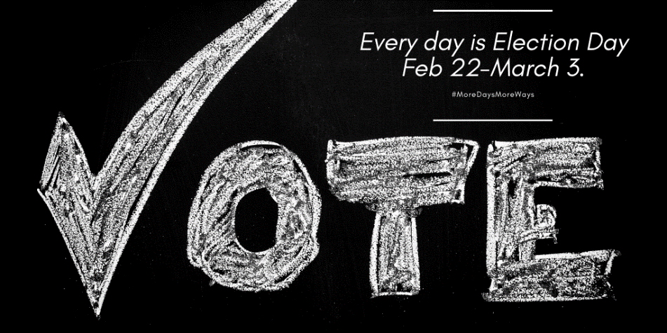

The following images have been formatted for Instagram.
To share a Tweet post on Instagram, take a screenshot of the Tweet, crop the image to show only the Tweet, and post to Instagram. Note that if you want to share a county link on Instagram you will need to add the link to your bio - links in posts are not clickable.
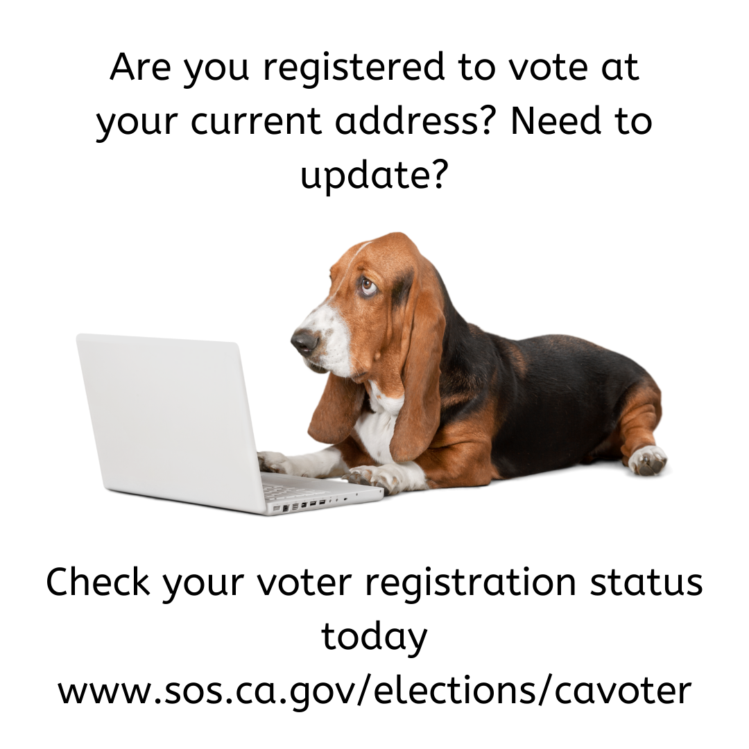

Additional Resources

Voter’s Edge California, votersedge.org @votersedge
Voter’s Edge California (VEC) is a joint project of MapLight and the League of Women Voters of California Education Fund (LWVCEF). Voter’s Edge California is a comprehensive, nonpartisan online guide to elections covering federal, state, and local races in the state of California.
Help get the word out about this great resource:

Sample Tweet: Want to know what is on your ballot? Need to locate a vote center? Visit votersedge.org to get the information you need.

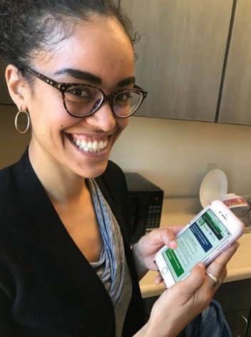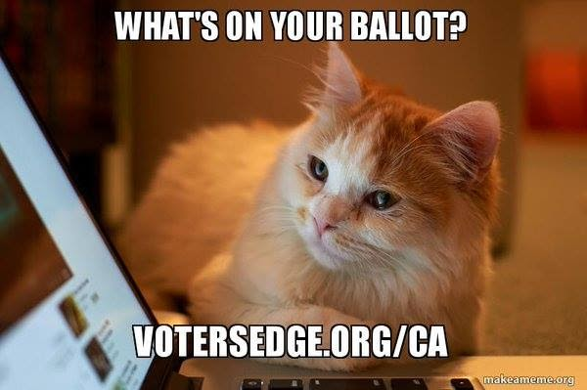

Voters Choice California, voterschoice.org @VotersChoiceCA
Voter’s Choice California (VCC) is a project of Future of California Elections, a nonpartisan nonprofit network promoting cross sector collaboration between election officials and nonprofit organizations. Launched in Spring 2017, the Voter’s Choice California project seeks to support county election offices and community organizations who are transitioning to the new voting model under the California Voter’s Choice Act (VCA). Learn more at voterschoice.org

