Help us spread the word on social media about the new, easy voting options available to voters in 15 California counties thanks to the Voter’s Choice Act. This toolkit is for the counties of Amador, Butte, Calaveras, El Dorado, Fresno, Madera, Mariposa, Napa, Nevada, Orange, Sacramento, San Mateo, Santa Clara, and Tuolumne. For the Los Angeles County Social Media Toolkit visit voterschoice.org/la.

Join our social media storms every Wednesday, January 15 - March 3 using #MoreDaysMoreWays.

Under the new law voters can return their ballots by mail, at a ballot drop box, or they can vote in-person at any vote center in their county, starting 10 days before Election Day and through Election Day, including weekends. Additionally, all voters in VCA counties, except Los Angeles County, will automatically receive a ballot in the mail, even if they did not request one.

Our research shows the following best practices for social media posts:
- Name your county in your post. Not all counties are doing elections under the Voter’s Choice Act, so be specific about your county. See appendix for handles and hashtags of the VCA counties.
- Tag your friends and partners to increase interactions. Feel free to tag us @VotersChoiceCA and we will retweet your post.
- Use #MoreDaysMoreWays to be part of the Twitter storm.

Thank you to our partners
the League of Women Voters of California and
the Voter’s Choice California Steering Committee
for their contributions to this resource.
This Social Media Toolkit is created for Twitter, but the postings and images may be used for Facebook and Instagram. Use #MoreDaysMoreWays to be part of the Twitter storm at 10am on Wednesdays starting January 15.

Wednesday, January 15: E-48
The Presidential Primary is less than two months away. Voters in [INSERT COUNTY] have #MoreDaysMoreWays to vote. Are you ready to vote? www.sos.ca.gov/elections/cavoter

Not registered with a political party? You will be mailed a nonpartisan ballot, which will not list presidential candidates, unless you contact your county elections office [INSERT COUNTY WEBSITE]

Wednesday, January 22: E-41, State and County Voter Information Guides mailings begin on Jan 23
Voters in [INSERT COUNTY] have #MoreDaysMoreWays to vote. Your party registration matters when voting for President. Learn the special rules for the Presidential Primary. www.sos.ca.gov/elections/voting-info/how-vote-president

Voters in [INSERT COUNTY] will receive their ballots in the mail. Is your address current? Check your voter registration status today www.sos.ca.gov/elections/cavoter Voters in [INSERT COUNTY] have #MoreDaysMoreWays to vote.

Wednesday, January 29: E-34, Vote by Mail ballots are on their way
Keep an eye on your mailbox. All voters in [INSERT COUNTY] will receive their ballot in the mail. Voters in [INSERT COUNTY] have #MoreDaysMoreWays to vote. Learn more at [INSERT COUNTY WEBSITE]

Check your mailbox. Voter guides and ballots are on their way! Every registered voter in [INSERT COUNTY] will receive a ballot in the mail. Learn more at [INSERT COUNTY WEBSITE] #MoreDaysMoreWays

Wednesday, February 5: E-27, Ballot drop boxes are available throughout the county starting E-29, Feb 3
Get ready to vote. Update your registration by February 18 to get your ballot and all election materials by mail. www.sos.ca.gov/elections/cavoter

Is your ballot ready to go? Return your ballot today at any drop box in [INSERT COUNTY] or by mail. No postage needed. Don’t forget to sign your envelope! [INSERT COUNTY WEBSITE] #MoreDaysMoreWays

Wednesday, February 12: E-20, Valentines Day Feb 14, Registration deadline for administrative purposes closes on Feb 18
We LOVE to VOTE! And now [INSERT COUNTY] voters have #MoreDaysMoreWays. Drop off ballot or vote in-person starting Feb. 22. Learn more at [INSERT COUNTY WEBSITE]
We LOVE Voting! Make sure you’re ready by updating or register by Feb. 18 to get mailed a ballot and election materials https://registertovote.ca.gov/. If you miss the date, voters in [INSERT COUNTY] may visit any vote center starting Feb. 22 to register and vote in-person #MoreDaysMoreWays

Wednesday, February 19: E-13, Vote centers open Saturday Feb 22
Not registered to vote? Voters in [INSERT COUNTY] can register and vote at any vote center starting Sat Feb 22. Yes, you can vote on a Saturday! [INSERT COUNTY WEBSITE] #MoreDaysMoreWays

Everyday is Election Day Feb 22 through March 3! Voters in [INSERT COUNTY] have #MoreDaysMoreWays. Find out more [INSERT COUNTY WEBSITE]

Wednesday, February 26: E-6, all vote centers open countywide Feb 29-March 3,
[INSERT COUNTY] voters can vote today! Mail your ballot, drop it off or vote in-person at any vote center starting Feb 22 through March 3 #MoreDaysMoreWays

Vote early and avoid the lines! Voters in [INSERT COUNTY] can visit any vote center starting Feb 22. And even vote on the weekend. Find out where [INSERT COUNTY WEBSITE] #MoreDaysMoreWays

Daily Tweets Friday, February 28 to Tuesday, March 3

Friday, Feb 28
Vote early and skip the line! Drop off your ballot or vote in-person at any vote center in [INSERT COUNTY] this weekend. Learn more [INSERT COUNTY WEBSITE] #MoreDaysMoreWays

You can still register and vote at any vote center in [INSERT COUNTY]. Go today and through March 3. Learn more [INSERT COUNTY WEBSITE] #MoreDaysMoreWays

Saturday, Feb 29
Avoid the lines on Election Day and vote today! Visit any vote center in [INSERT COUNTY] or drop off your ballot at a ballot drop box (no postage needed). Learn where [INSERT WEBSITE] #MoreDaysMoreWays

Celebrate Leap Day and Vote! Vote at ANY vote center in [INSERT COUNTY] today. Learn where to go [INSERT COUNTY WEBSITE] #MoreDaysMoreWays

Sunday, March 1
Skip the lines and vote today! All vote centers are open and you can vote at any location in [INSERT COUNTY]. Learn where [INSERT COUNTY WEBSITE] #MoreDaysMoreWays

It’s Sunday! Check off your To-Do List and vote today. Visit any vote center in [INSERT COUNTY]. Vote today, Don’t delay. Learn where [INSERT COUNTY WEBSITE] #MoreDaysMoreWays

Monday, March 2
Didn’t register to vote? It’s not too late. Register and vote at any vote center in [INSERT COUNTY]. Learn where [INSERT COUNTY WEBSITE] #MoreDaysMoreWays

Avoid the lines tomorrow and vote today! Don’t wait. Visit any vote center in [INSERT COUNTY] or drop off your ballot. Learn where [INSERT COUNTY WEBSITE] #MoreDaysMoreWays

Tuesday, March 3 - Election Day!

It’s Election Day! Bring your BFF, your parents, siblings, partners, co-workers, dog, cat -ok not your dog or your cat - but any other eligible voter and visit any vote center in [INSERT COUNTY] to register and vote the same day. [INSERT COUNTY WEBSITE] #MoreDaysMoreWays

Not registered to vote? No problem. Visit any vote center in [INSERT COUNTY] to register and vote the same day. [INSERT COUNTY WEBSITE] #MoreDaysMoreWays

Last day to vote! Have your voice heard. Visit any vote center in [INSERT COUNTY] to register and vote the same day. [INSERT COUNTY WEBSITE] #MoreDaysMoreWays

It’s Election Day! Still have a mail ballot? Drop it off at any vote center in [INSERT COUNTY]. Learn where [INSERT COUNTY WEBSITE] #MoreDaysMoreWays

Go vote! You can still register and vote today. Visit any vote center in [INSERT COUNTY] Learn where [INSERT COUNTY WEBSITE] #MoreDaysMoreWays

Lost your ballot? Visit any vote center in [INSERT COUNTY] to vote. Learn where [INSERT COUNTY WEBSITE] #MoreDaysMoreWays

It’s Election Day! Want to vote? It’s not too late. Visit any vote center in [INSERT COUNTY] to register and vote the same day. Learn where to go [INSERT COUNTY WEBSITE] #MoreDaysMoreWays

Using social Media Graphics in Posts
Use graphics to attract attention to your post. Save the images on your computer as a .png or .gif by hitting right click on the image and selecting “save as picture.”
Make images more accessible. Instructions for how to add descriptions and enhance accessibility on social media platforms are available in this accessible social media tutorial.
To share a Tweet post on Instagram, take a screenshot of the Tweet, crop the image to show only the Tweet, and post to Instagram. Note that if you want to share a county link on Instagram you will need to add the link to your bio - links in posts are not clickable.
Feel free to use any of the images in this toolkit. They were developed from public free stock images.

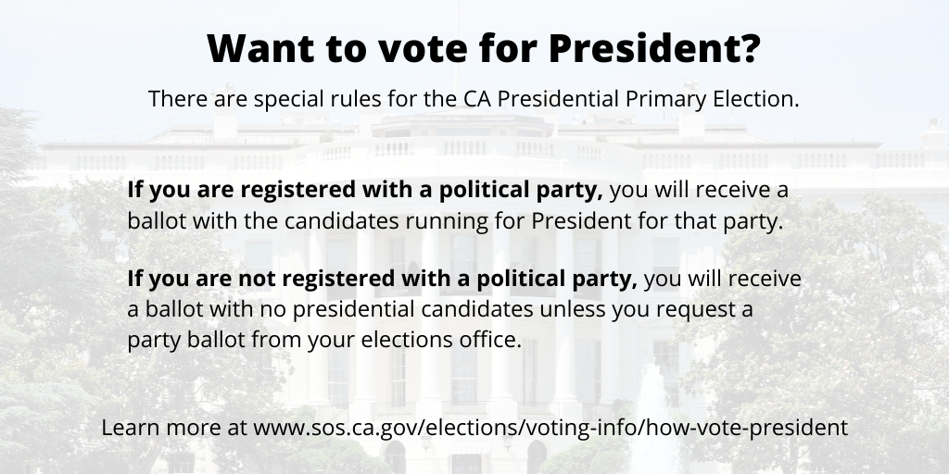

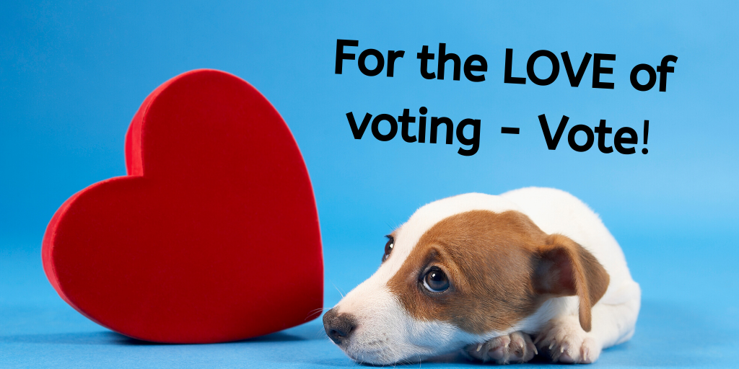

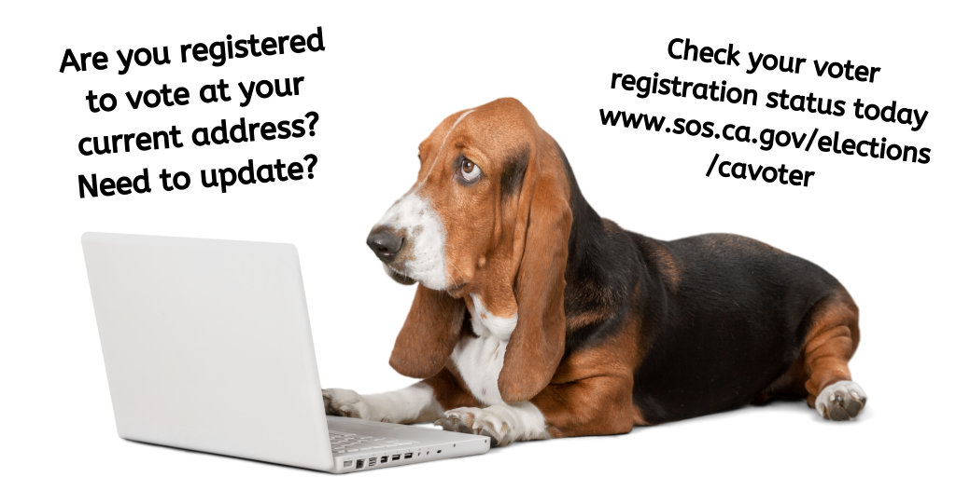

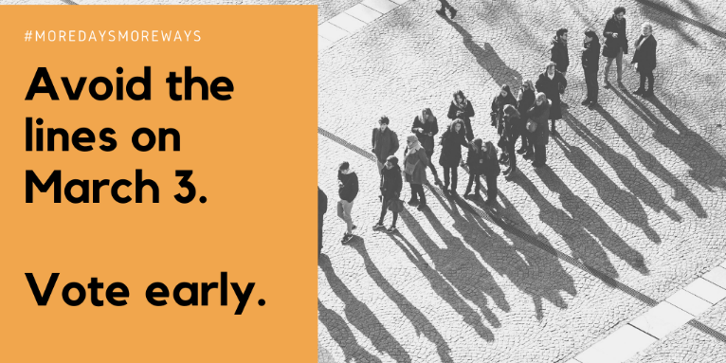
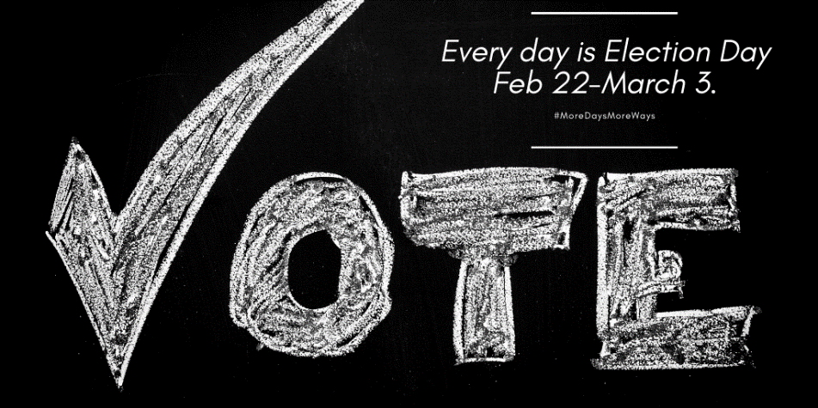

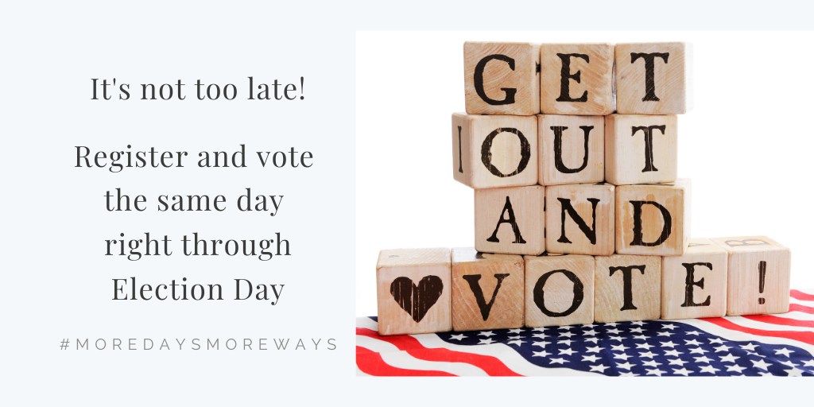

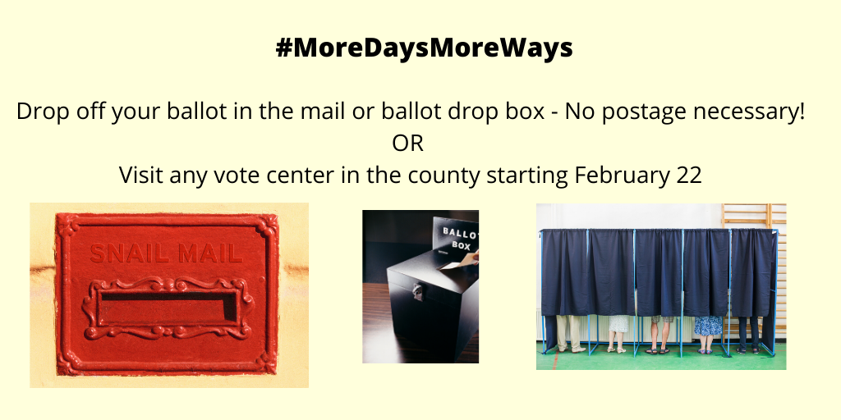

The following images have been formatted for Instagram.

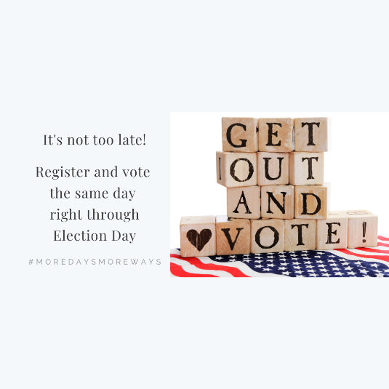
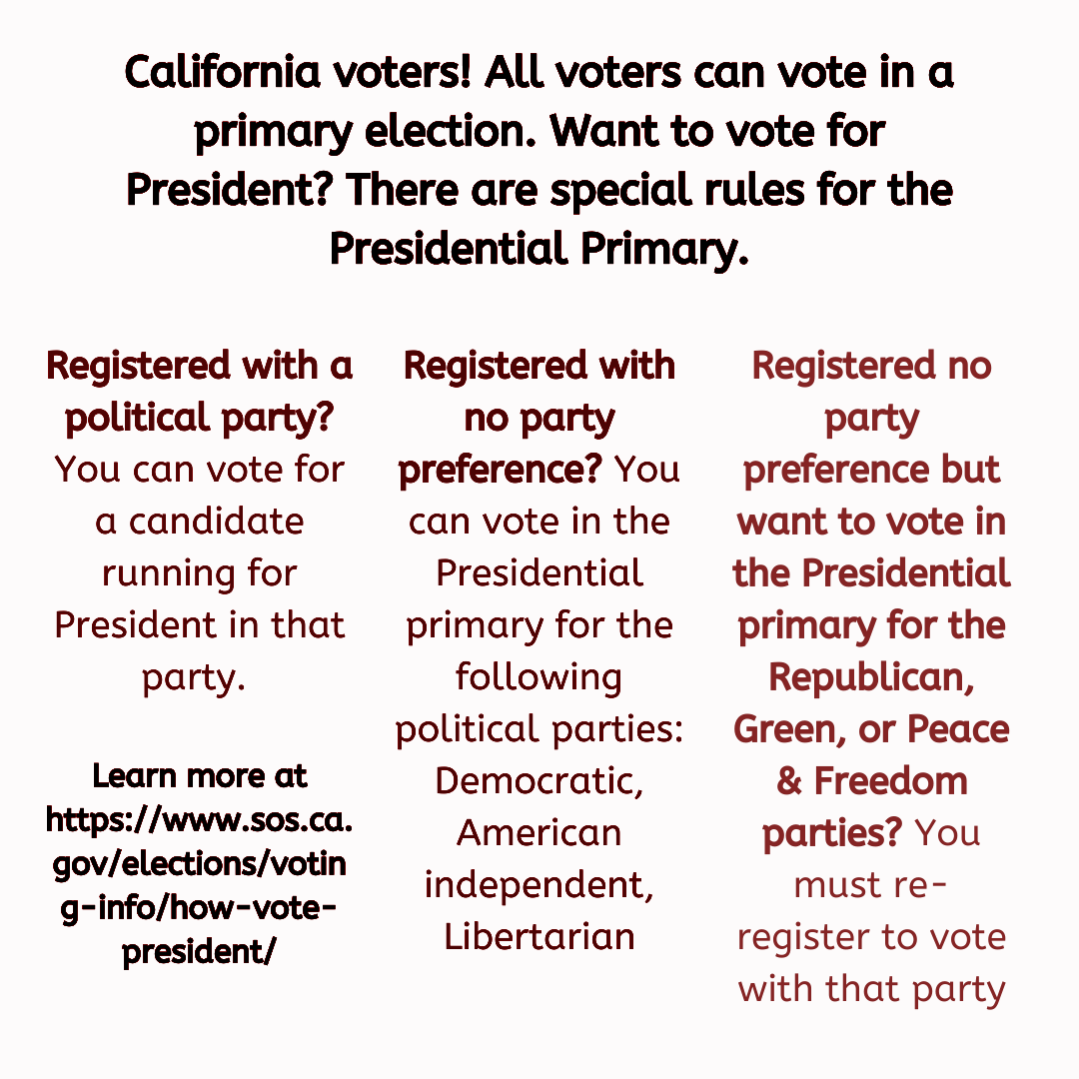

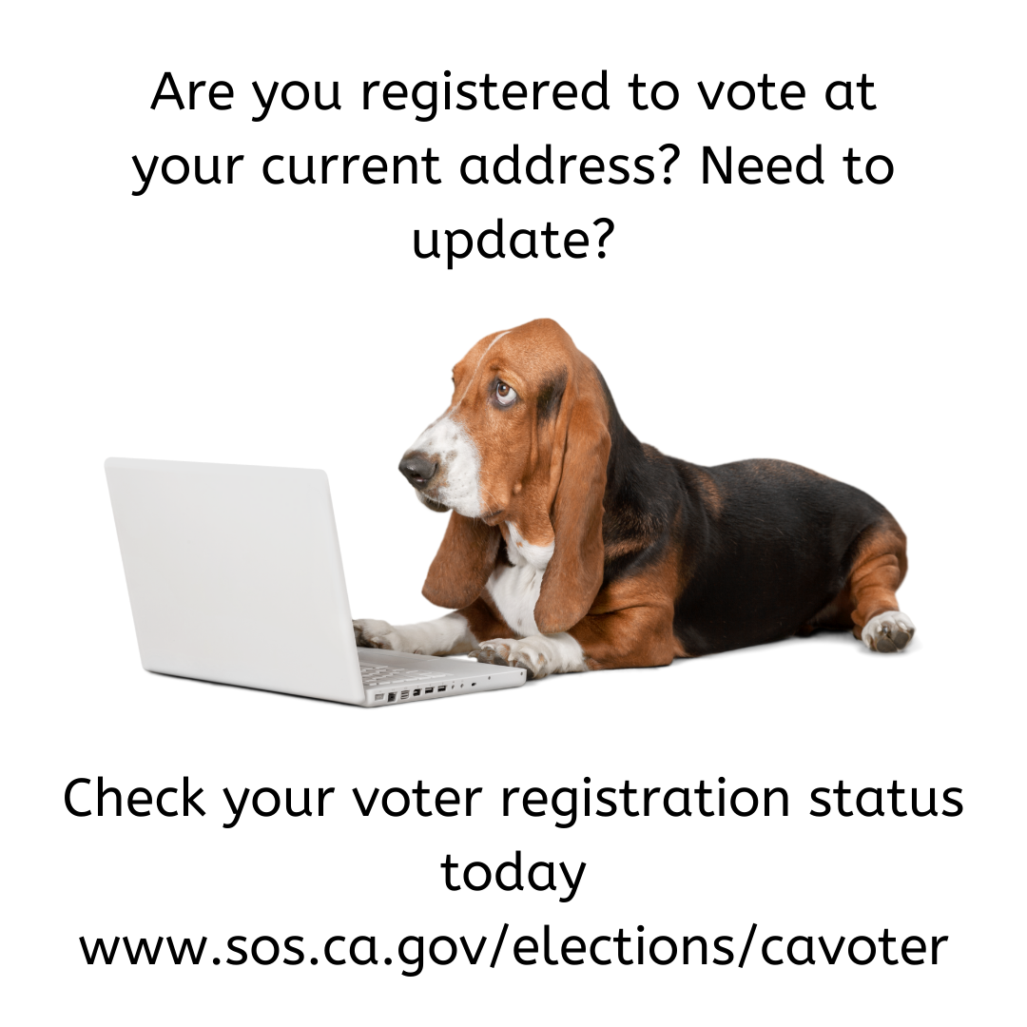

Official County Election Websites & Social Media Information

Amador
https://www.amadorgov.org/government/elections
@AmadorCounty

Butte
https://clerk-recorder.buttecounty.net/elections/electhome.html
@CountyofButte, @buttevotes

Calaveras
https://elections.calaverasgov.us/
@CalaverasCR

El Dorado
https://www.edcgov.us/Government/Elections
@EDCElections, @CountyElDorado

Fresno
https://www.co.fresno.ca.us/departments/county-clerk-registrar-of-voters
@FresnoCountyCA

Los Angeles
https://www.lavote.net/home/voting-elections
@LACountyRRCC
#LAVotes

Madera
votemadera.com/vca
@MaderaElections, @MaderaCounty

Mariposa
https://www.mariposacounty.org/87/Elections
@MariposaCounty

Napa
https://www.countyofnapa.org/396/Elections
@CountyofNapa
Hashtags: #VoteNapa

Nevada
https://www.mynevadacounty.com/2320/Voters-Choice-Act
Twitter handle: @NevCoElections, @NevadaCountyCA

Orange
https://www.ocvote.com/
@OCRegistrar
#ocvote2020 #ocvotecenters2020

Sacramento County
http://www.elections.saccounty.net/VoteCenters/Pages/Locations-Vote-Centers.aspx
@SacCountyCA, @SacramentoVote
#VoteSacramento, #SacCountyVotes

San Mateo County
www.smcvote.org
@smcvote, @sanmateoco
#VoteSanMateo, #smcvote

Santa Clara
https://www.sccgov.org/sites/rov/pages/registrar-of-voters.aspx
@sccvote, @SCCgov

Tuolumne
https://www.tuolumnecounty.ca.gov/194/Election-Information
@TuolumneCoElect, @TuolumneCountyC

Additional Resources

Voter’s Edge California, votersedge.org @votersedge
Voter’s Edge California (VEC) is a joint project of MapLight and the League of Women Voters of California Education Fund (LWVCEF). Voter’s Edge California is a comprehensive, nonpartisan online guide to elections covering federal, state, and local races in the state of California.
Help get the word out about this great resource:

Sample Tweet: Want to know what is on your ballot? Need to locate a vote center? Visit votersedge.org to get the information you need.

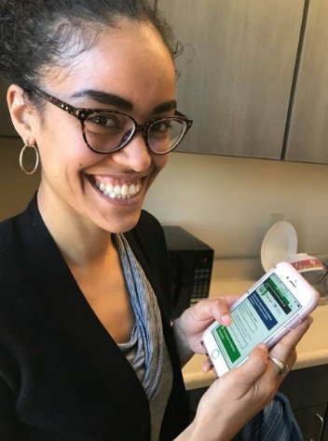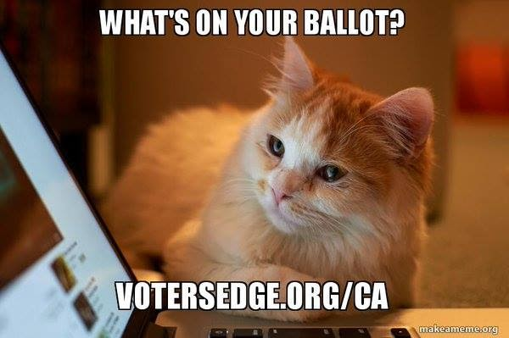

Voters Choice California, voterschoice.org @VotersChoiceCA
Voter’s Choice California (VCC) is a project of Future of California Elections, a nonpartisan nonprofit network promoting cross sector collaboration between election officials and nonprofit organizations. Launched in Spring 2017, the Voter’s Choice California project seeks to support county election offices and community organizations who are transitioning to the new voting model under the California Voter’s Choice Act (VCA). Learn more at voterschoice.org

