Elections Toolkit: Educational and Shareable Assets
bit.ly/alc-elections

Hashtags:
Main: #Election2020 #AAPI2020
Secondary: #CAVotes #AAPIVote
Tertiary: #CAVotesSafely #CAVotesEarly

Purpose:
In response to the potential barriers the COVID-19 pandemic brings to our community members, the state of California is offering several ways to vote in the 2020 General Election. The purpose of this toolkit is to offer social media resources for partners to share and educate AAPI communities in California on how to participate in the 2020 General Election.

How to Vote in the 2020 General Election - You Have Options!

Vote from Home
All registered voters in California will receive a ballot in the mail, which they can return 1) by mail, 2) at a secure ballot drop box and/or the county elections office, or 3) at an in-person voting site. You can even track the location of your ballot and receive notifications about its location.

Vote In-Person (and Vote Early!)
Early voting will be available in almost all counties, from October 31 through November 3 (Election Day). Many counties will offer consolidated voting sites for the first time, some counties will offer their standard polling places, and many other counties will offer vote centers as they have previously under the Voter’s Choice Act. The state and counties will have safety guidelines for voting sites, including maintaining physical distance and wearing face-coverings.

Language Access
Language assistance differs by county. If you vote by mail, call your county elections office to find out what is available in your preferred language in your county. If you vote at a polling place, ask if translated materials are available and if the staff present speaks your preferred language. You can also look for signs in your language. You can access factsheets on language access in voting that explain what resources are available in your language.

Key Messaging Dates:

September 14, 2020 | 50 Days before Election Day: Remind voters to register or update their address and language preference.
September 17, 2020 | 2020 National Citizenship Day: Remind voters to register or update their address and language preference.
September 22, 2020 | National Voter Registration Day: Remind voters to register or update their address and language preference.
October 5, 2020 | Counties start mailing ballots to all active registered voters.
October 19, 2020 | Unofficial but recommended last day to register & still get a ballot in the mail. After this date, you can still register--check with your county for more information.
October 24, 2020 | In a few counties, 10-day vote centers open.
October 27, 2020 | Unofficial but recommended last day to mail your ballot back. After this date, drop off at the elections office, a voting place, or a ballot drop box.
October 31, 2020 | Early voting begins (available in most counties)
November 1-2, 2020 | Early voting continues (available in most counties)
November 3, 2020 | Election Day

Sample Social Media Posts

ACT NOW TO RECEIVE YOUR BALLOT

Week of 9/14: Ballots arriving in the mail and language options

- Voting is our voice and power that honors the legacies of AAPI leaders who fought for our voting rights! It’s a great time to check your registration status: VoterStatus.sos.ca.gov #Election2020 #AAPI2020

- Given what's at stake, the effort to prevent #POC voting this year is strong -- but our votes won’t be suppressed in one of the most important elections yet! Check your registration status: VoterStatus.sos.ca.gov #Election2020 #AAPI2020

- The most important election of our lifetimes is coming up! You will automatically get a ballot mailed to you in early October, so now’s the time to make sure you’re registered to vote at VoterStatus.sos.ca.gov #Election2020 #AAPI2020 #CAVotes

- ATTN CA Voters! Our ballots are now almost as diverse as we are! Depending on your county, you can get translated materials or vote in different languages--28 languages have assistance available. Go to VoterStatus.sos.ca.gov to select your language. #Election2020 #AAPI2020

Graphics of the week:
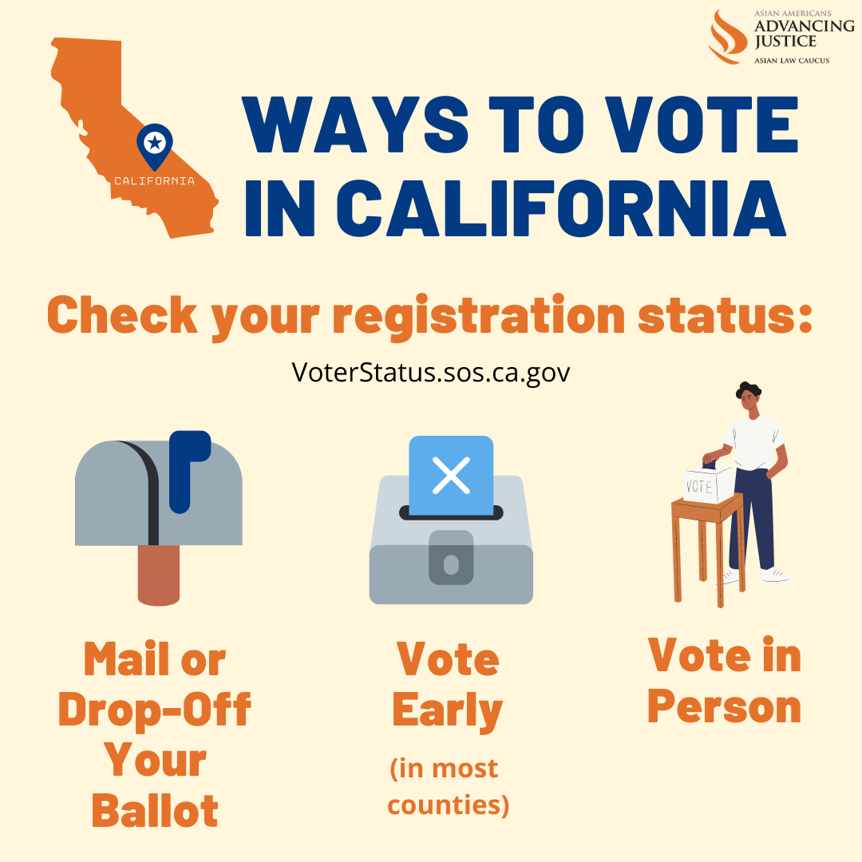Download 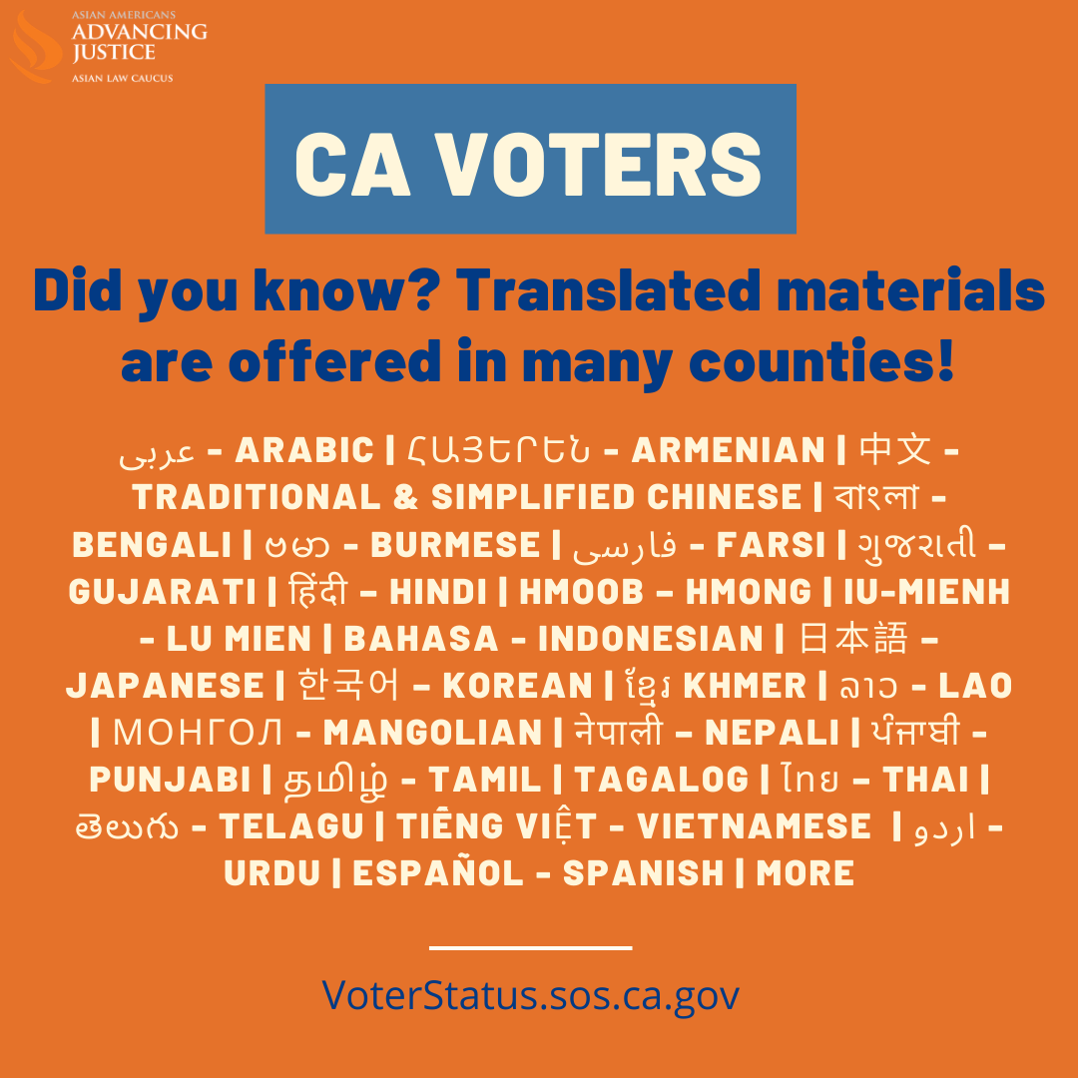Download

9/17: National Citizenship Day - Check your status and/or register to vote

- It’s #NationalCitizenshipDay! Are you a recently naturalized citizen? Make sure you’re registered to vote! Translated material & ballots are available in many languages. Check your registration and sign up for translated materials at VoterStatus.sos.ca.gov #Election2020 #AAPI2020

- This #NationalCitizenshipDay, let’s celebrate those recently naturalized by making sure you are registered to vote!
➡️Check your status: VoterStatus.sos.ca.gov
➡️Register: RegisterToVote.ca.gov
#Election2020 #AAPI2020

Graphics of the Day:
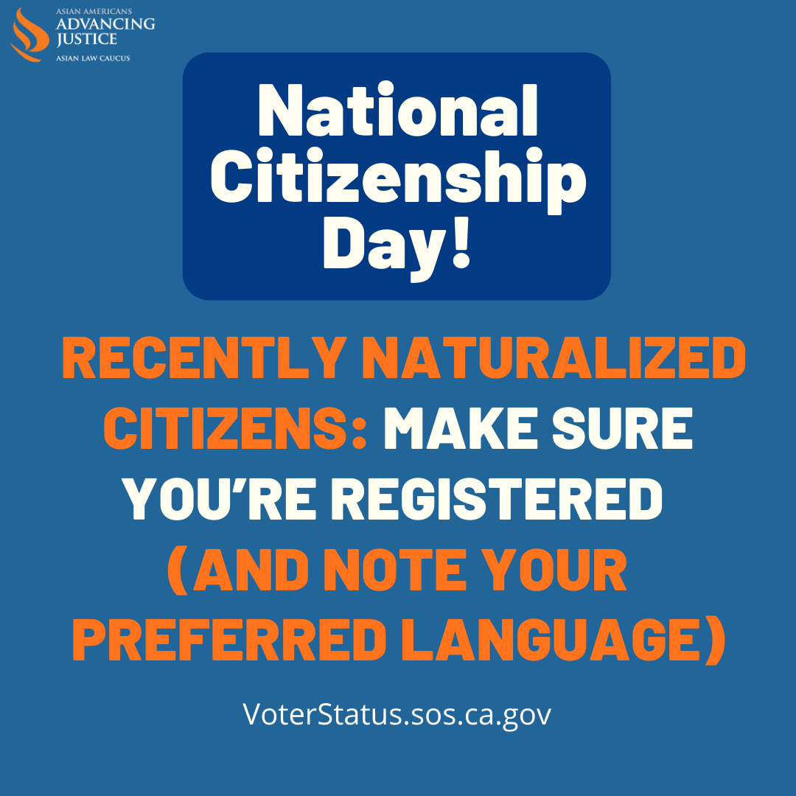Download

Week of 9/21: Sign up to track your ballot

- Did you know you can track your vote-by-mail ballot to know when it’s
✅ Mailed
✅ Received
✅ Counted
Sign up to receive automatic email, text, or voice call notifications at WheresMyBallot.sos.ca.gov #Election2020 #AAPI2020

- Our ballots are coming in the mail next week! If you haven’t registered to vote, yet, then let’s hustle and go to RegisterToVote.ca.gov #Election2020 #AAPI2020

- If you’re in California, your ballot will be mailed to you soon! You can track it’s journey to and from you at: WheresMyBallot.sos.ca.gov #Election2020 #AAPI2020

Graphic of the week:
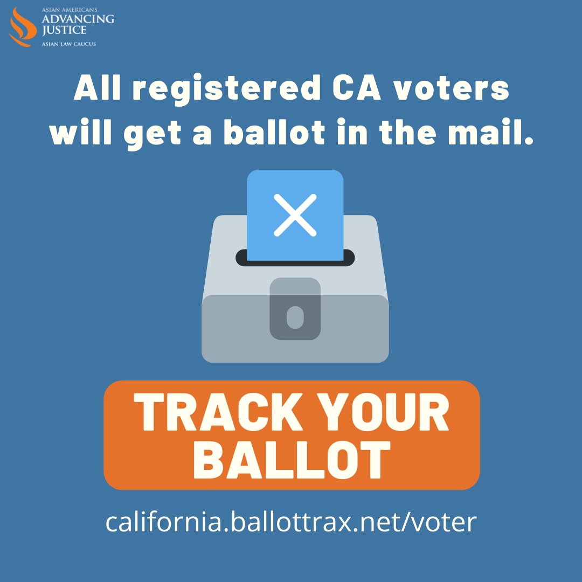Download

9/22: National Voter Registration Day

- What better day to register to vote than #NationalVoterRegistrationDay? Join thousands of community members across the country today: RegisterToVote.ca.gov
#Election2020 #AAPI2020 #NVRD

- Happy #NationalVoterRegistrationDay! Need language assistance?
For vote by mail, update your language preference at VoterStatus.sos.ca.gov/ or call your county elections office. #Election2020 #AAPI2020 #NVRD

Graphic of the day:
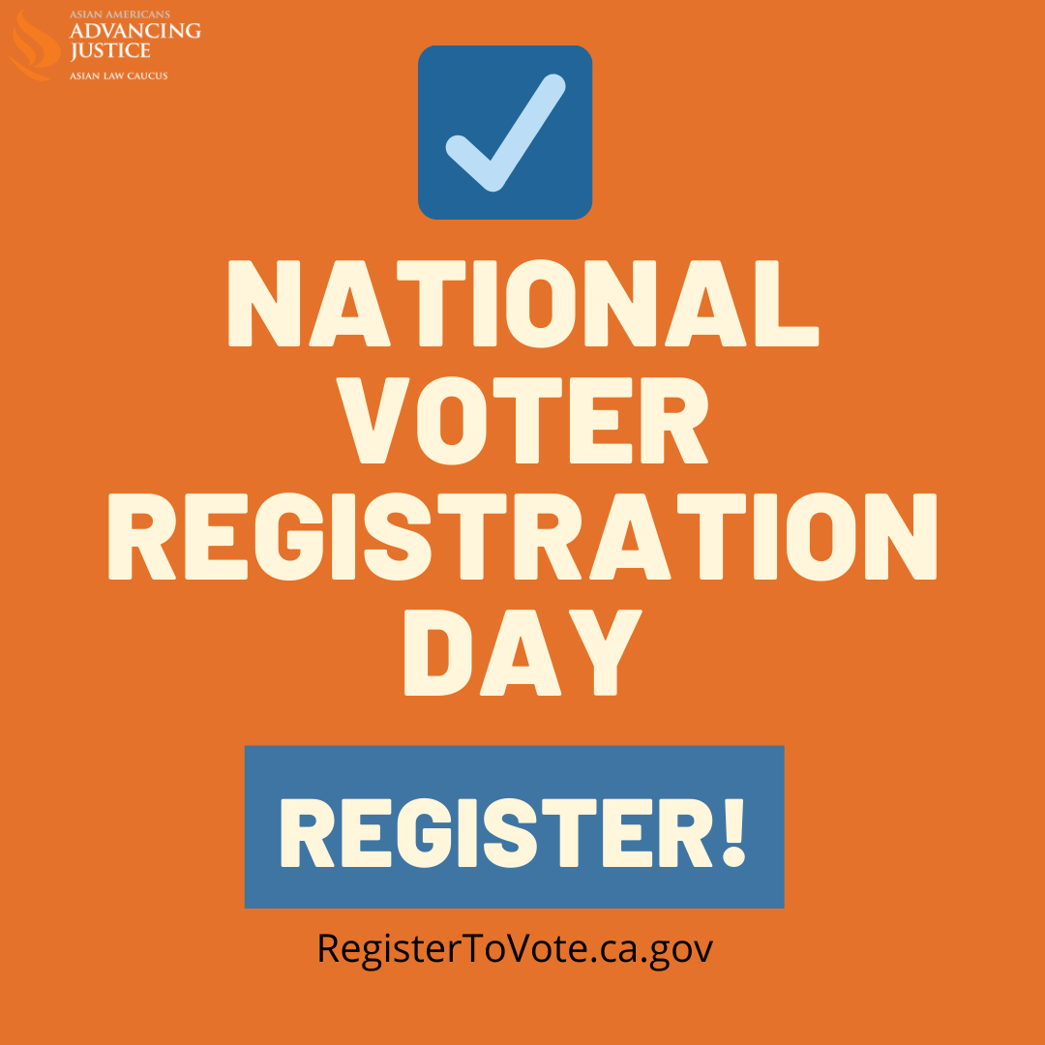Download

Week of 9/28: Promote online voter registration and remind voters to check and update voter registration (especially address and language preference)

- The election is around the corner, so let’s get ready to vote! Before ballots get sent out on Oct. 5, you can triple check you’re registered to vote with updated mailing address and language preference at VoterStatus.sos.ca.gov #Election2020 #AAPI2020 #CAVotes

- This is one of the most important elections of our lifetime. Make your voice heard! Registertovote.ca.gov or check your VoterStatus.sos.ca.gov. Your ballot is coming to you. Make sure your address is current and select your language preference. #Election2020 #AAPI2020

- Moved? You need to update your address to vote. All voters automatically get their ballot in the mail this week. To update your address, visit RegisterToVote.ca.gov #Election2020 #AAPI2020 #CAVotes

- Let’s keep democracy alive and thriving by voting this #Election2020! Check your registration status and update your language preferences today: VoterStatus.sos.ca.gov #Election2020 #AAPI2020 #AAPIvote

Graphics of the week:
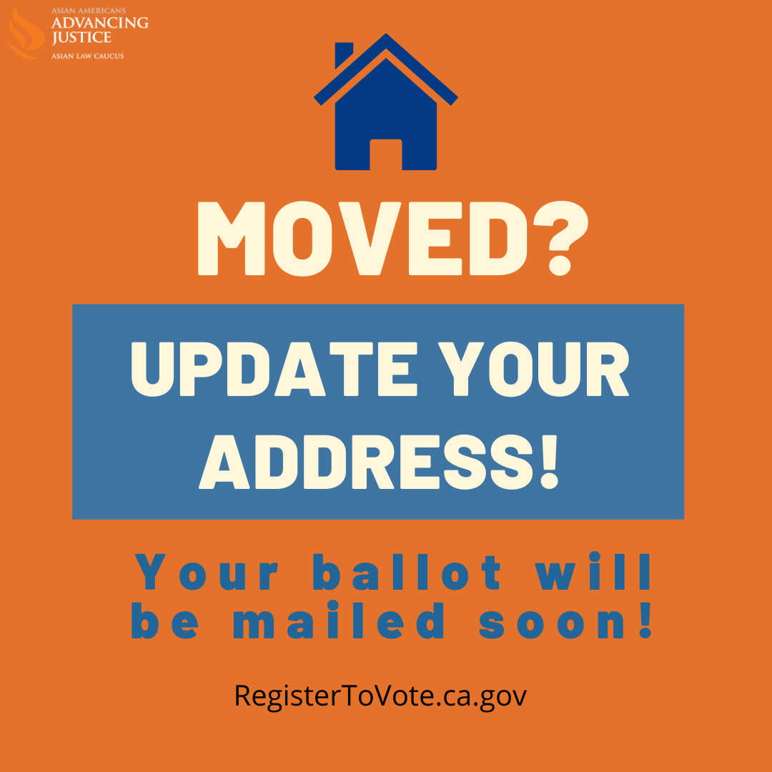Download 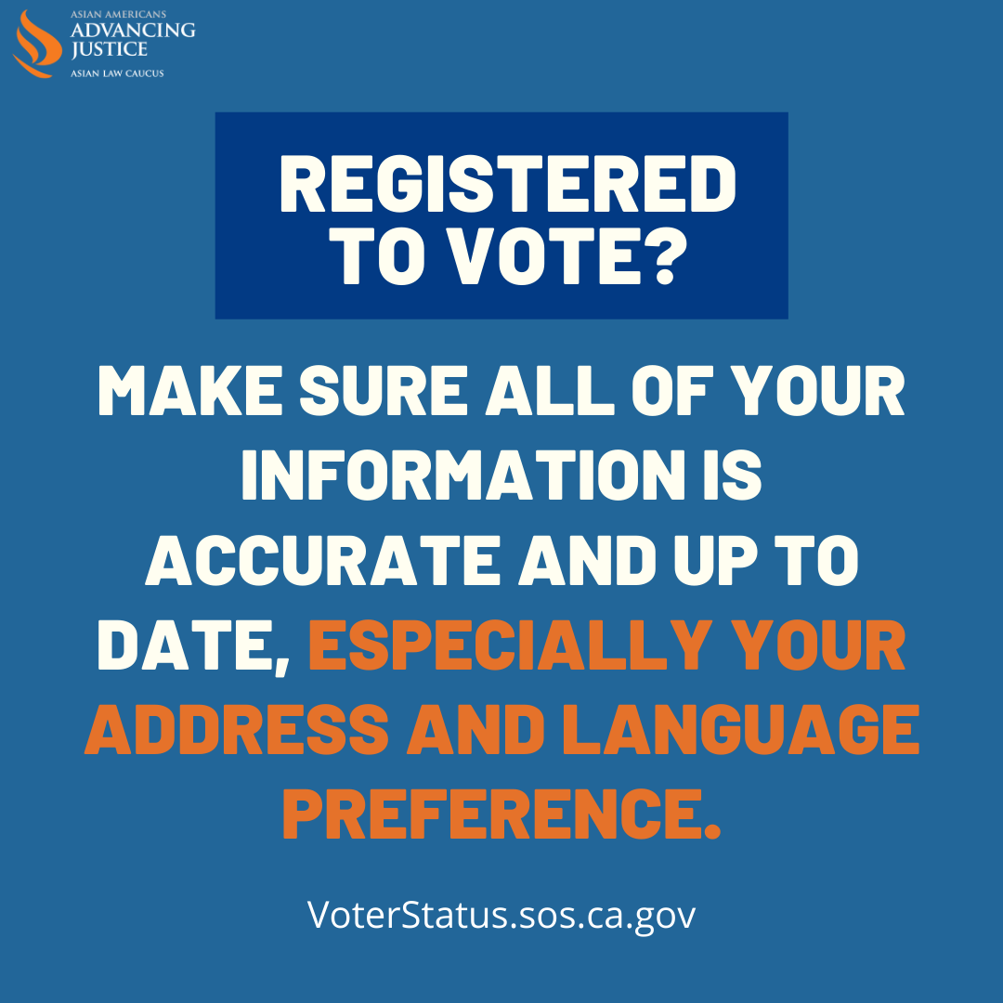Download

MULTIPLE WAYS TO VOTE

Week of 10/5: Ballots are mailed; voters will get their ballot in the mail but have options for voting

- Voting by mail is one of the easiest and safest ways to make your voice heard this #Election2020! Check your county’s options at: CAEarlyVoting.sos.ca.gov #AAPI2020 #CAVotesEarly #CAVotesSafely
  - Carousel graphic on rules per county?

- Every CA voter will automatically get their ballot in the mail.
You can return it:
➡️ By mail
➡️ At a ballot drop box (most counties)
➡️ In-person
Learn more about your county: sos.ca.gov/elections/voting-resources/county-elections-offices #Election2020 #AAPI2020
THREAD 2/2:
*Don’t forget: ✅Seal, ✅Sign, ✅Date the envelope.*
If you’re mailing on Election Day, make sure the mail pickup hasn’t occurred yet, or go into a post office to get your ballot “hand canceled” by a postal worker.

- We need you to cast your #AAPIVote! Our voices are crucial this #Election2020. You can cast your vote ➡️ by mail, ➡️ at a ballot drop box, or ➡️ in-person. Go to your county elections site for more details sos.ca.gov/elections/voting-resources/county-elections-offices #AAPI2020

- ‼️ATTN CA Voters: Voting in-person will be available in almost all counties, and early voting may be available in your county . Check your county’s voting options: sos.ca.gov/elections/voting-resources/county-elections-offices #Election2020 #AAPI2020 #CAVotes

Graphics of the week:
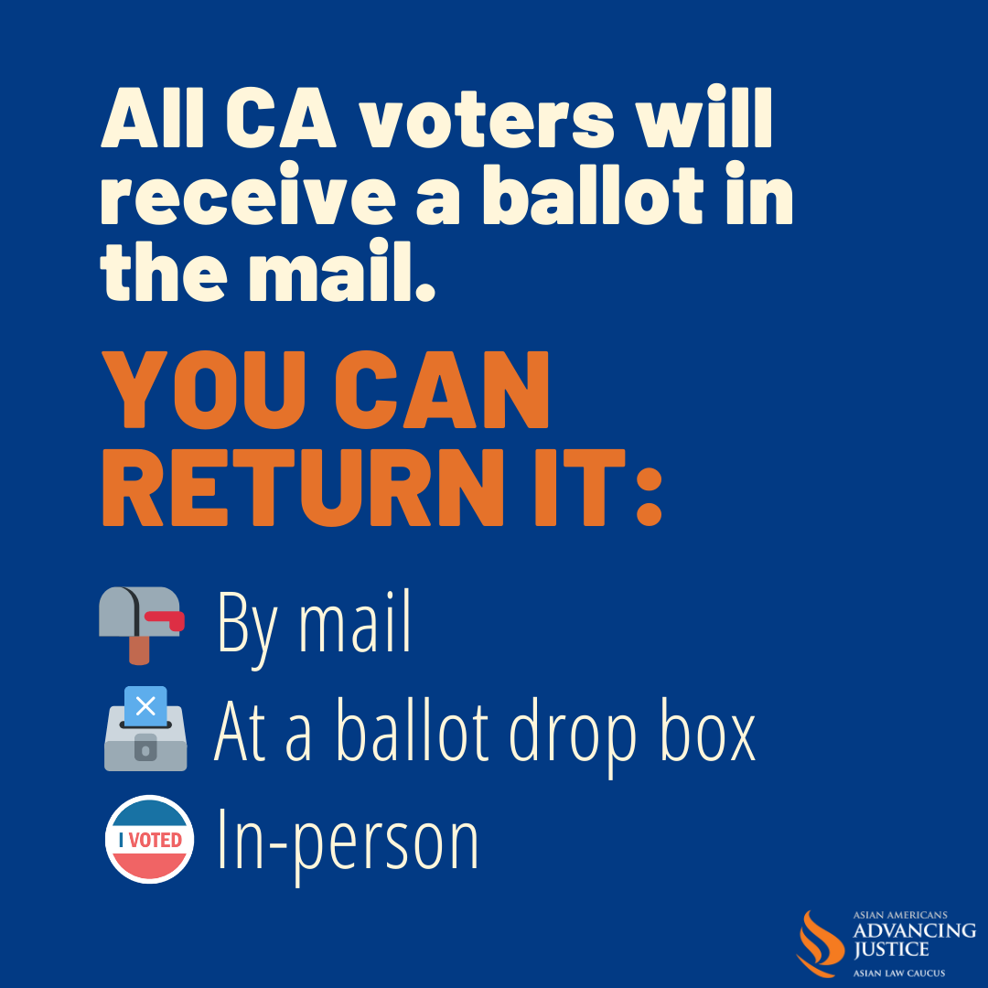Download

VOTE FROM HOME

Week of 10/12: Voters will receive a ballot in the mail; they can mail it back early and track it

- Did your neighbors receive a ballot in the mail, but you didn’t? Update your address by re-registering at RegisterToVote.ca.gov/, then sign up to track your ballot at california.ballottrax.net/voter #Election2020 #AAPI2020

- You’ll get a ballot in the mail soon if you are an active registered voter. Check your status at VoterStatus.sos.ca.gov - and it’s not too late to register to vote! #Election2020 #AAPI2020

- 🗺️ Where’s my ballot?
🔍 Track it by signing up at california.ballottrax.net/voter/
#Election2020 #AAPI2020

- Follow your ballot’s trip from when first mailed to you to when it’s counted by signing up for tracking at california.ballottrax.net/voter/ #Election2020 #AAPI2020

- Don’t have to wait until Election Day to mail back your ballot. Return it today!
*Seal, Sign and Date the envelope.* No postage needed. Or drop it off yourself at a ballot box. Sign up to track your ballot at california.ballottrax.net/voter #Election2020 #AAPI2020 #CAVotesEarly

Graphic of the week:
Download

10/19: Recommended last day to register and still get a ballot in the mail

- Vote from the comfort of your home! If you plan on voting by mail, it’s the LAST DAY to register and still get a ballot in mail! RegisterToVote.ca.gov #Election2020 #AAPI2020 #CAVotes

- Are you planning on voting by mail? ‼️ Be sure to register today to make sure there’s time to still get a ballot in the mail! Don’t wait: RegisterToVote.ca.gov #Election2020 #AAPI2020 #CAVotes

Week of 10/19: Same day registration

- All registered California voters are receiving their ballots. Not registered yet? You can register & vote the SAME DAY. Find out how: sos.ca.gov/elections/voter-registration/same-day-reg #Election2020 #AAPI2020 #CAVotes

- CA Voters: You can register and vote all in one visit right up through #ElectionDay. But don’t wait, learn where to go today! sos.ca.gov/elections/voter-registration/same-day-reg #Election2020 #AAPI2020 #CAVotes

Graphic of the week:
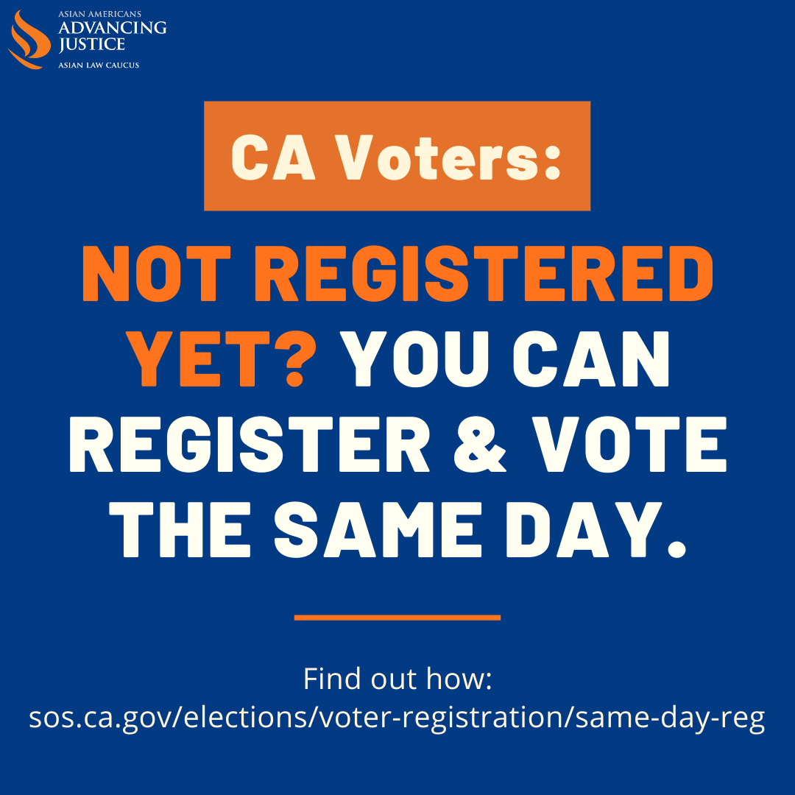Download

Week of 10/26: Voters can vote early in-person starting the weekend before Election Day, and even earlier in some counties

- Be among the first to vote early. You have many ways to vote this election. Return your ballot today at a mailbox or drop box.
⚠️ Don’t forget to seal, sign and date the envelope ⚠️ or check where to vote in-person this weekend. Visit CAEarlyVoting.sos.ca.gov #Election2020 #AAPI2020

- Vote Early - you don’t have to wait until Election Day to cast your vote! Check where to go CAEarlyVoting.sos.ca.gov/ #Election2020 #AAPI2020

- Voting at home? Seal, sign, and date the envelope and put it in the mail today. No postage needed. You can also drop it off at any voting location or drop box in your county. Find a location near you sos.ca.gov/elections/polling-place #Election2020 #AAPI2020

- Election Day is the LAST day you can vote... But you don’t have to wait! You can vote early. Check where to go CAEarlyVoting.sos.ca.gov #Election2020 #AAPI2020

Graphic of the week:
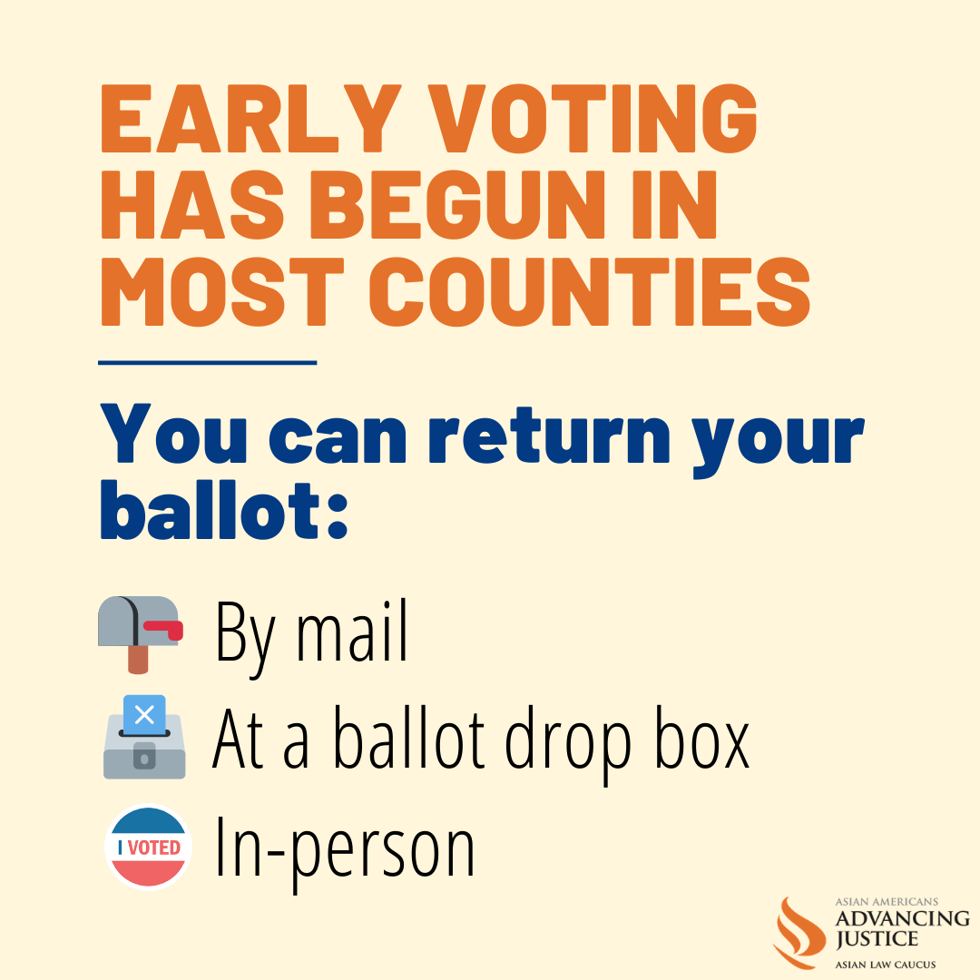Download

10/27: Recommended last day to mail in ballot, afterwards we suggest that voters find a drop box or drop it off at a voting site

- Don’t miss your chance to have your #AAPIVote counted by mail! We recommend you mail in your ballot TODAY to make sure it gets to elections officials on time. You can also look for a ballot drop box or a voting site. #Election2020 #AAPI2020

- 📬 Remember to mail your ballot! We recommend putting it in the mail today. Make sure it’s ✅Sealed, ✅Signed, ✅Dated (no postage needed)! #Election2020 #AAPI2020
  - THREAD 2/2
Don’t fret - you can still find a ballot drop off or voting location to drop off your ballot up through Election Day! sos.ca.gov/elections/polling-place #Election2020 #AAPI2020

Graphic of the week:
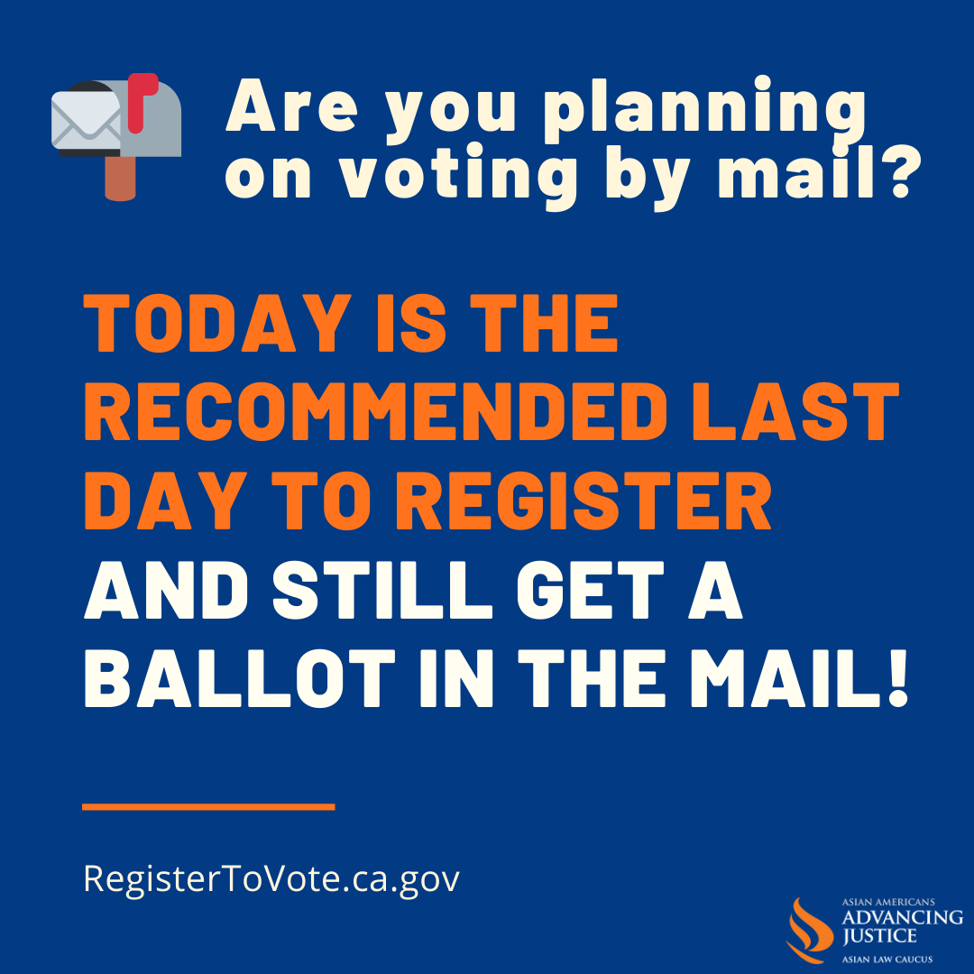Download

10/31: Happy Halloween, drop off your ballot or vote in-person (most counties)

- 👻 #HappyHalloween! Missing the chance to make your voice heard in this election is too scary. Vote today. Just seal, sign, date your ballot and drop it off at a drop box or voting location near you. You can also vote in-person at CAEarlyVoting.sos.ca.gov #Election2020 #AAPI2020 👻

- 👻 Boo-tiful day to Vote! Drop off your ballot at any drop box. Seal, Sign and Date the envelope or visit a voting location near you CAEarlyVoting.sos.ca.gov #Election2020 #AAPI2020

11/1: Remind voters to vote early (most counties), address safety concerns

- You can vote safely in person! Make sure to stay socially-distanced & wear a face covering when visiting a voting location today, drop off your completed ballot at a voting location or ballot drop box near you! CAEarlyVoting.sos.ca.gov/ #CAvotessafely #Election2020 #AAPI2020

- You can vote today! Safely register & vote on the same day at a voting location near you! OR Seal, Sign and Date your ballot and drop it off at any voting location or drop box in your county CAEarlyVoting.sos.ca.gov/ #Election2020 #AAPI2020

- The last day to vote is Nov. 3 but you can register and vote TODAY at a voting location in your county. Find out more at: CAEarlyVoting.sos.ca.gov/ #Election2020 #AAPI2020

- This November keep voting locations safe for voters and election workers! You can skip the line by voting early at an early voting location, turning in your completed vote-at-home ballot, & following safety procedures. Learn more: Vote.ca.gov #Election2020 #AAPI2020

- Need to vote in person or need assistance? Make sure to wear a mask or face shield
to visit a voting location near you CAEarlyVoting.sos.ca.gov #Election2020 #AAPI2020

Graphic of the day:
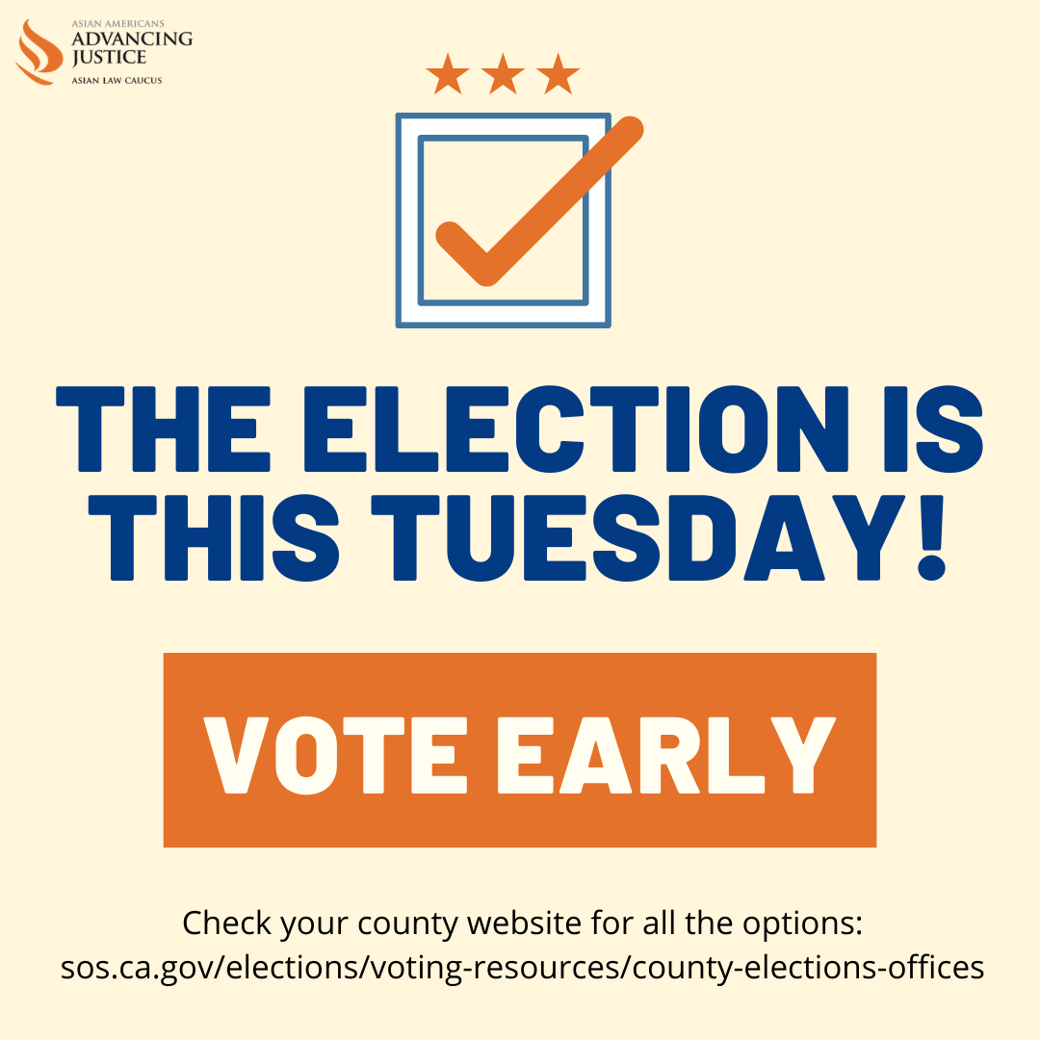 Download

11/2: Last chance to vote early, tomorrow is Election Day!

- There is a lot at stake this #Election2020, meaning the effort to prevent #POC voting this year is powerful. Don’t let them win! Find your location place: sos.ca.gov/elections/polling-place #AAPI2020

- Tomorrow is ELECTION DAY - but you can vote now at a voting location near you! Don’t wait: sos.ca.gov/elections/polling-place #Election2020 #AAPI2020

- Avoid the lines & vote safely TODAY before Election Day! Visit a voting location near you to cast your ballot, or drop off your ballot sos.ca.gov/elections/polling-place #Election2020 #AAPI2020 #CAVotesSafely

- Planning to vote in person tomorrow? You may encounter long lines, so bring food, water, and reading materials to pass the time! Find your polling place: sos.ca.gov/elections/polling-place #Election2020 #AAPI2020

Graphic of the day:
Download

11/3 – Election Day!

- 🗳️Planning to vote in person today? We suggest bringing your water bottle, snacks, and reading materials to pass the time! Find your polling place: sos.ca.gov/elections/polling-place #Election2020 #AAPI2020
  - Thread 2/2: If you received a ballot in the mail, you can fill it out at home and then drop it off at your polling place to avoid the lines.

- 🗳️It’s #ElectionDay! Return your ballot today. Seal, Sign and Date the envelope - No postage needed! Drop it off at a voting location or drop box near you or vote safely in-person. Learn where to go sos.ca.gov/elections/polling-place #Election2020 #AAPI2020

- 🗳️Want to vote today but not sure if you’re registered? You can still register and vote in one visit at a voting location in your county! sos.ca.gov/elections/polling-place #Election2020 #AAPI2020

- 🗳️Don’t want to vote in-person? Drop off your ballot at any drop box or voting location near you. Find where to go sos.ca.gov/elections/polling-place #Election2020 #AAPI2020

- 🗳️Your vote isn’t just for you, it’s for family, neighborhood & community. Today is when you can show your support for all! sos.ca.gov/elections/polling-place #Election2020 #AAPI2020 🌟

Graphics of the day:
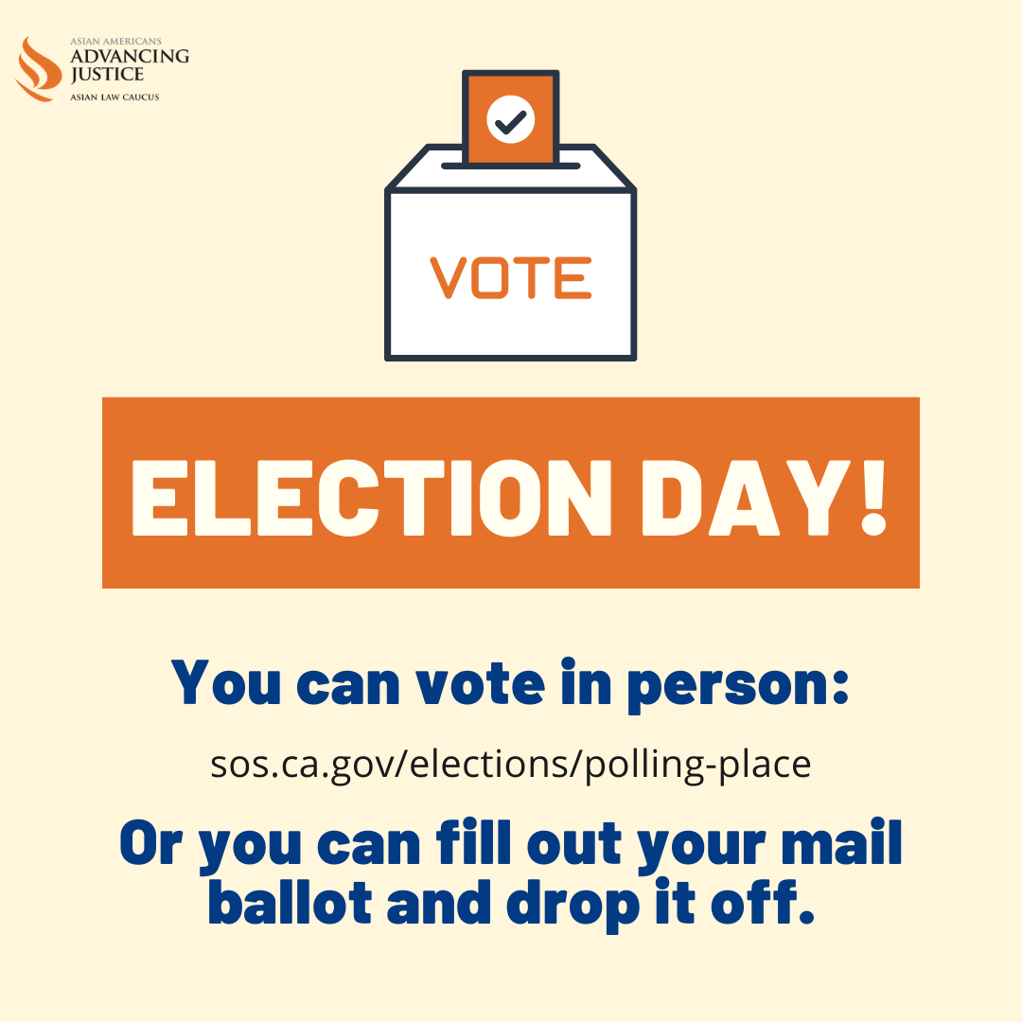Download 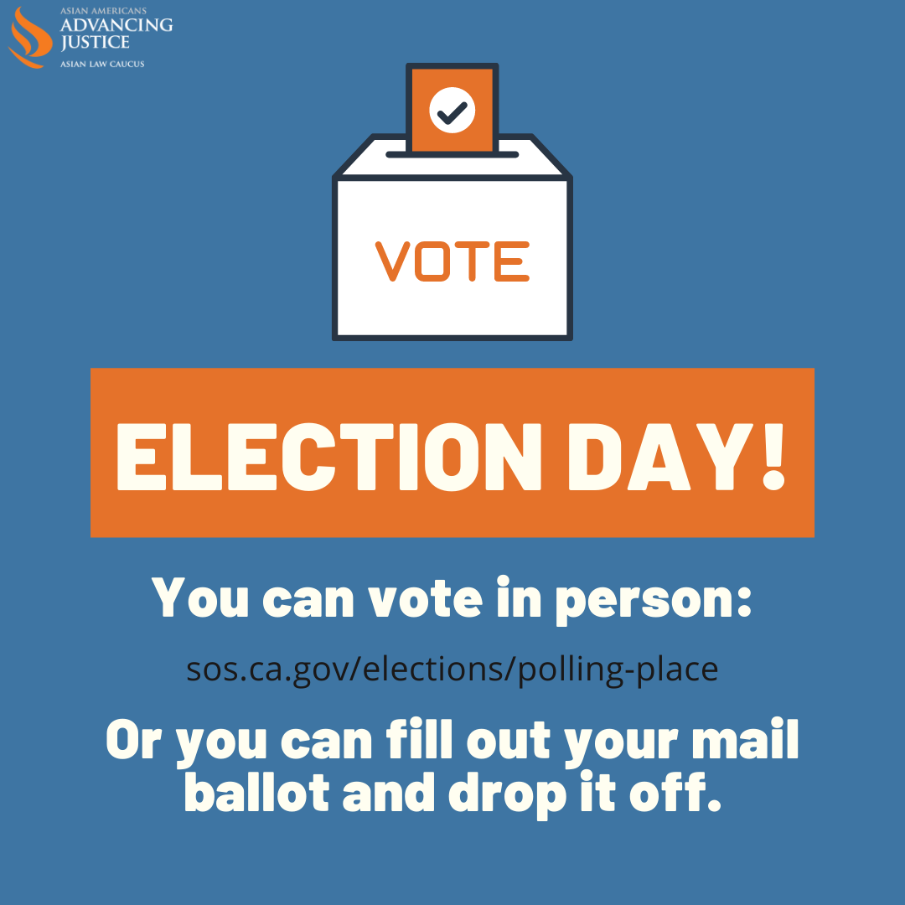Download

Graphics:

All graphics linked above can be found in this folder.
- “Get Ready to Vote” graphics and translations can be found in this sub-folder.

If you would like to edit or add your logos to any of these graphics, you can do so in this Canva file.

Important Links & Phone Numbers

REGISTRATION
Register to Vote | registertovote.ca.gov
Voter Status | voterstatus.sos.ca.gov
Same Day Registration | www.sos.ca.gov/elections/voter-registration/same-day-reg
BALLOT TRACKING
Where is My Ballot | california.ballottrax.net/voter
WHERE TO VOTE
Early Voting Locations | caearlyvoting.sos.ca.gov
Voting Location Lookup | www.sos.ca.gov/elections/polling-place
Contact Your Election Office | www.sos.ca.gov/elections/voting-resources/county-elections-offices
VOTER RIGHTS
Voter Bill of Rights in English and other languages | www.sos.ca.gov/elections/voter-bill-rights
Time Off to Vote | www.sos.ca.gov/elections/time-vote-notices
POLL WORKER INFO
Sign Up to be a Poll Worker | pollworker.sos.ca.gov/s/
How to Be a Poll Worker | www.sos.ca.gov/elections/poll-worker-information
OTHER
Election Myths Busted | www.sos.ca.gov/elections/election-2020/election-myths
In-Language Voter Hotlines from Secretary of State | (800) 345-VOTE (8683) – English  (800) 232-VOTA (8682) - español / Spanish  (800) 339-2857 - 中文 / Chinese  (888) 345-2692 - हिन्दी / Hindi  (800) 339-2865 - 日本語 / Japanese  (888) 345-4917 - ខ្មែរ / Khmer  (866) 575-1558 - 한국어 / Korean  (800) 339-2957 - Tagalog  (855) 345-3933 - ภาษาไทย / Thai  (800) 339-8163 - Việt ngữ / Vietnamese  (800) 833-8683 – TTY/TDD

Bay Area voters: Do you need language translation assistance?

Find language coverage below, by county:
County | Translated ‘Facsimile Ballots’ | Translated Votable Ballots and Other Materials
Alameda (510) 272-6973 | Burmese, Hindi, Khmer, Korean, Laotian, Mien, Mongolian, Punjabi, Telugu | Chinese, Spanish, Tagalog, Vietnamese
Contra Costa  (925) 335-7800 | Hindi, Korean*, Laotian, Nepali, Punjabi, Tagalog*, Tamil, Telugu, Vietnamese* | Chinese, Spanish
Marin (415) 473-6456 | Spanish, Vietnamese | --
Napa (707) 253-4321 | Tagalog | Spanish
San Francisco  (415) 554-4375 | Burmese, Japanese, Korean, Tagalog, Thai, Vietnamese | Chinese, Spanish
San Mateo (650) 312-5222 | Burmese, Hindi, Japanese, Korean, Tagalog | Chinese, Spanish
Santa Clara (408) 299-8683  or (866) 430-8683 | Gujarati, Nepali, Punjabi, Tamil, Telugu | Chinese, Korean, Khmer, Japanese, Hindi, Spanish, Tagalog, Vietnamese
Solano (707) 784-6675 or (888) 933-8683 | Spanish, Tagalog | --
Sonoma (707) 565-6800 or (800) 750-8683 | Khmer, Spanish, Tagalog, Vietnamese | --

*Translated, votable ballots should be available for in-person voting.

Additional Resources for How to Vote in the November Election
- Nov. Election FAQ from the Future of California Elections
- Know-Your-Voting-Rights Factsheets
- Language Access in Voting Factsheets

