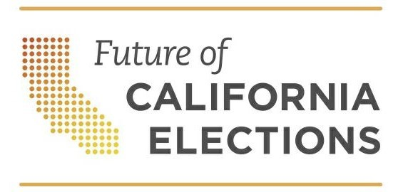

Prepared for the 2020 Presidential Primary Election

Same Day Voter Registration
Toolkit for Community Organizations

Last updated February 2020

This toolkit provides plain-language text and sample materials to support voter education. It was prepared in collaboration with the ACLU of California, Asian Americans Advancing Justice-Asian Law Caucus, Center for Civic Design, League of Women Voters of California, Santa Barbara Registrar of Voters, and Santa Cruz County Registrar of Voters.
Founded in 2011, Future of California Elections (FoCE) is a nonpartisan network of election officials, reform, civil rights and civic engagement groups working in collaboration to modernize elections and expand participation in California. This and other voter education resources are available at futurecaelections.org

Introduction
The Same Day Voter Registration Toolkit for community organizations provides plain-language text and sample materials to support voter education on same day voter registration. Feel free to copy and paste the text and images in this toolkit.
A major disappointment for a voter is learning they cannot vote on Election Day because of an issue with their voter registration. Same Day Voter Registration, officially known as Conditional Voter Registration, has the potential to improve the voter experience by allowing them to register right through to Election Day.
Until recently, same day voter registration was limited to specific locations. With the passage of SB 72 in 2019, Same Day Voter Registration is now available at every polling place in California, starting in the 2020 Presidential Primary Election. Voters who reside in a Voter’s Choice Act county can visit any vote center starting 10 days before Election Day to register and vote on the same day.
The ability to register and vote on the same day will be especially important during the 2020 Presidential Primary Election because of rules set by each political party for voting for President.

Part 1. Sample Language for Same Day Voter Registration Education
Want to vote in the 2020 Presidential Primary Election?
You can register to vote right through Election Day. You will also be able to register and vote at your voting place on Election Day.
You can quickly and easily register to vote online at Registertovote.ca.gov at any time. You can also contact your elections office to request a paper registration form.

After February 18, 2020, you may also be able to register and vote on the same day at a designated location or your voting place. Voters residing in a Voter’s Choice Act county listed below can go to any vote center starting February 22.

- Amador
- Butte
- Calaveras
- El Dorado
- Fresno
- Los Angeles
- Madera
- Mariposa
- Napa
- Nevada
- Orange
- Sacramento
- San Mateo
- Santa Clara
- Tuolumne

Not sure if you are registered?
Check your voter registration status at voterstatus.sos.ca.gov or call 800-345-VOTE (8683).

Remember, political party affiliation matters for the presidential primary election. Learn more at www.sos.ca.gov/elections/voting-info/how-vote-president

Part 2. Sample Language for the Presidential Primary Election
Want to vote for President? There are special rules.
The Democratic Party, American Independent Party and Libertarian Party allow voters who are not registered with a political party to vote their party’s ballot. Requesting one of these party ballots for the presidential primary does not change your voter registration. Read below to learn how to request a party ballot.

The Green Party, Peace and Freedom Party, and Republican Party allow only voters registered with their party to vote in their presidential primary. To vote for one of these parties’ candidates, you need to change your voter registration. You can always re-register again after the election with any political party or as a “No Party Preference” voter. Register or re-register online at Registertovote.ca.gov by February 18, 2020 to save time and avoid lines. You may still register after February 18 at your voting place or designated location up to and including Election Day, March 3, 2020.

Voting In-person?
If you are registered with a political party when you arrive at your voting place, you will be handed a ballot with the candidates running for president for that party.
If you are not registered with a political party, you will select a ballot from the following choices when you arrive at your voting place: Nonpartisan ballot (will not list presidential candidates), a Democratic Party ballot, an American Independent Party ballot or a Libertarian Party ballot.
You will need to change your voter registration to vote for the Green Party, Peace & Freedom Party, or Republican Party candidates if registered with another party. You can always re-register again after the election as either a “No Party Preference” voter or with any political party.

Want to vote for President? There are special rules.
The Democratic Party, American Independent Party and Libertarian Party allow voters who are not registered with their political party to vote their party’s ballot. Requesting one of these party ballots for the presidential primary does not change your voter registration. Read below to learn how to request a party ballot.

The Green Party, Peace and Freedom Party and Republican Party only allow voters registered with their party to vote in their presidential primary. To vote for these parties’ candidates, you need to change your voter registration. You can always re-register again after the election as either a “No Party Preference” voter or with any political party. Register or re-register online at Registertovote.ca.gov by February 18, 2020 to save time and avoid the lines. You may still register after February 18 at your voting place or designated location up to and including Election Day, March 3, 2020.
Voting by mail?
If you are registered as a permanent vote by mail voter with a political party, you will receive a ballot with the candidates running for president for that party.
If you are registered as a permanent vote by mail voter but are not registered with a political party, you will be mailed a nonpartisan ballot, which will not list presidential candidates, unless you contact your elections office to request a partisan ballot.
The last day to request a vote by mail ballot from your elections office is February 25, 2020.

If you live in any of the following VCA counties, you will receive a ballot by mail, even if you did not request one.

- Amador
- Butte
- Calaveras
- El Dorado
- Fresno
- Madera
- Mariposa
- Napa
- Nevada
- Orange
- Sacramento
- San Mateo
- Santa Clara
- Tuolumne

Part 3. Sample Social Media Graphics
A best practice for social media is to use a graphic to attract your audience’s attention. Below are a few sample images. You can save these on your computer as a .png (the png format is recommended) by hitting right click on the image and selecting “save as picture.” This will download in the local folder you select.

Optimized in size for Instagram:
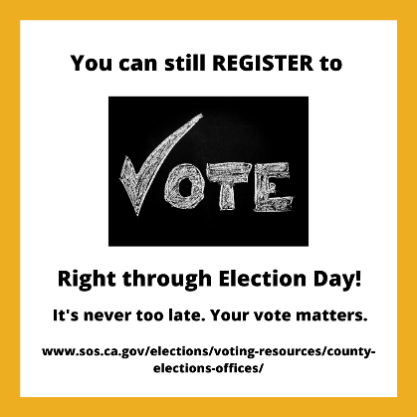 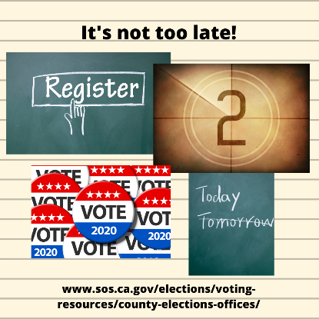c

Optimized in size for Facebook:
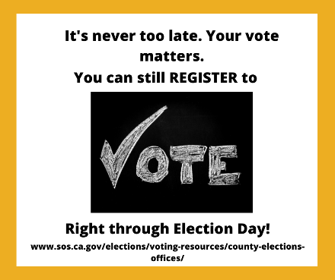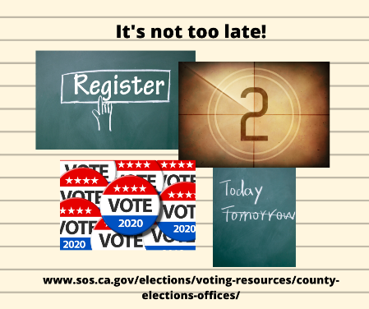

Optimized in size for Twitter:

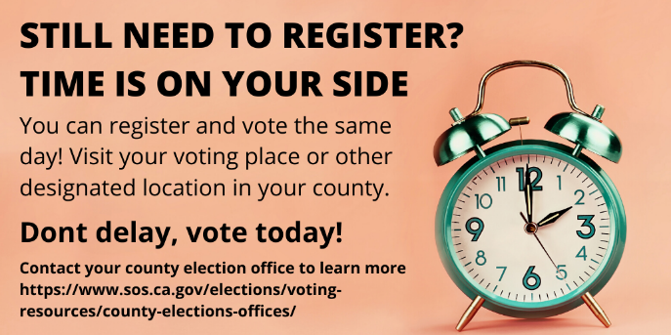

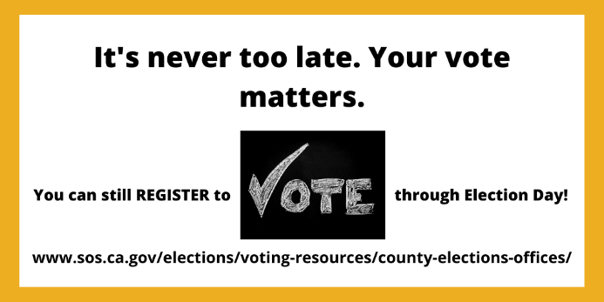

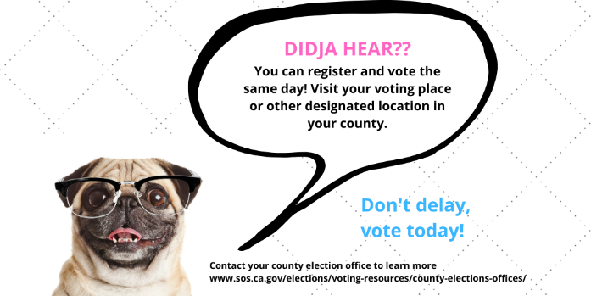

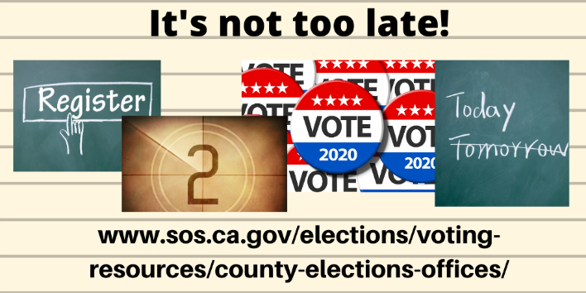

Part 4. Frequently Asked Questions
Where do I check if I am registered to vote?
Visit voterstatus.sos.ca.gov to look up your registration.

Where should I register and vote after February 18?
After February 18, you can register to vote online at https://registertovote.ca.gov/.

You can also visit your polling place on Election Day, or avoid the lines by registering and voting early at a location designated by your election office. Click the following link to find where to go www.sos.ca.gov/elections/polling-place

If you reside in any of the following Voter’s Choice Act counties listed below, you can register and vote starting 10 days before Election Day and through Election Day at any vote center.

- Amador
- Butte
- Calaveras
- El Dorado
- Fresno
- Los Angeles
- Madera
- Mariposa
- Napa
- Nevada
- Orange
- Sacramento
- San Mateo
- Santa Clara
- Tuolumne

Click the following link to find your voting place www.sos.ca.gov/elections/polling-place

Will my ballot be counted?
Your ballot will be counted if:
- Your signature on the ballot envelope matches the one on your voter registration form.
- You provide all the information needed to identify you on your voter registration form -- including your name, home (residence) address, and date of birth.
- This is the only ballot you cast in this election.

Is this voter registration good for the next election, too?
Yes. You are now permanently registered to vote under the name and address on your voter registration form. Remember that you will need to update your registration if you move, change your name, or want to change your political party.

What is the voter registration deadline?
Thanks to same day voter registration, the deadline is now an administrative deadline. Voters can register to vote right through Election Day. The 15-day administrative deadline for the March 3, 2020 Presidential Primary is February 18, 2020. (Since the 15th day before the election is a holiday, the deadline is moved to the next business day.)

Why does the voter registration “administrative” deadline matter?
There are several milestones as we approach Election Day. The sooner you register to vote, the sooner you can utilize your elections office’s services.

- If you register 29 days before the election, you receive your state and county voter guide in the mail with all the information need to vote.
- If you register 15 days before the election, your name is on the voter list at your voting site and you still have time to vote by mail.

If you register after the 15th day, but before Election Day, you must go to a county office or designated location to register and vote. On Election Day, you can visit your polling place to register and vote. Be prepared to wait in line and fill out a form providing your name, residence, political party or no party, etc. Click the following link to find your voting place www.sos.ca.gov/elections/polling-place

If you reside in a county implementing the Voter’s Choice Act, you can register and vote all in one visit at any vote center in your county, starting 10 days before Election Day and through Election Day. Click here to find your voting place www.sos.ca.gov/elections/polling-place

Part 5. A voter decision chart (non-VCA counties)

If you: | You can go to: | How you vote:
Registered to vote before the 15-day deadline (February 18, 2020) | Any early voting location OR Your polling place | Vote by regular ballot
Are not registered to vote | Your county elections office or designated location in advance of Election Day. On Election Day, visit your polling place. | Complete a voter registration form  Vote using Same Day VR *
Moved and are registered in another county | Your new county elections office or designated location in advance of Election Day. On Election Day visit your new polling place. | Complete a voter registration form  Vote using Same Day VR *
Moved within the county where you are registered to vote | Your new county elections office or designated location in advance of Election Day. On Election Day, visit your new polling place. | Complete a voter registration form  Vote using Same Day VR *
Vote by mail, but do not have your vote by mail ballot | Your polling place | Vote by provisional ballot*
Are not near your polling place | Visit any polling place; however, you may not be able to vote in your local election. | Vote by provisional ballot*
Are not found in the voter list, or there are questions about your voter registration | Check your voter registration status at voterstatus.sos.ca.gov or call (800) 345-VOTE (8683) | Vote by provisional ballot*
*Your vote will be counted after election officials verify your voter registration and confirm you have not already voted in this election.

Part 6. Sample PowerPoint Slides
Integrating same day voter registration information into existing presentations is a great way to help voters learn about this new opportunity to register and vote on the same day.

Use the PowerPoint slides available at the following link.

Click here to access presentation slides in PowerPoint format

In 2020, Voter’s Choice Act counties include Amador, Butte, Calaveras, El Dorado, Fresno, Los Angeles, Madera, Mariposa, Napa, Nevada, Orange, Sacramento, San Mateo, Santa Clara and Tuolumne.
In 2020, Voter’s Choice Act counties include Amador, Butte, Calaveras, El Dorado, Fresno, Los Angeles, Madera, Mariposa, Napa, Nevada, Orange, Sacramento, San Mateo, Santa Clara and Tuolumne.

