08
Fall

Revised September 2014
California Online Voter Registration Community Outreach Toolkit

California Online Voter Registration (COVR) allows Californians to complete and submit their voter registration forms online in 10 languages: English, Spanish, Chinese, Hindi, Japanese, Khmer, Korean, Tagalog, Thai, and Vietnamese.

The Community Outreach Toolkit provides practical tools to support organizations promoting use of online voter registration in their community. Translated versions of the press release are available in Spanish, Chinese, Hindi, Japanese, Khmer, Korean, Tagalog, and Thai on our website at http://www.futureofcaelections.org/covr/

This Toolkit is made possible through the collaboration of the Future of California Election members:
Asian Americans Advancing Justice-Los Angeles
American Civil Liberties Union of California
California Forward
CALPIRG
Greenlining Institute
League of Women Voters of California Education Fund
Rock the Vote

www.futureofcaelections.org

TABLE OF CONTENTS
- The Voter Registration Gap in California 2
- Strategies for promoting online voter registration in your community 3
- Adding the COVR link button to your website 4
- Sample Outreach Documents 6
  - Outreach Email
  - Newsletter Article
  - Social Media Messages and Image
  - Press Release

- The Voter Registration Gap in California

There are 6 million Californians who are eligible to vote, but are not registered – which means that they cannot participate in the 2014 elections unless they register to vote. California is near the bottom of all states in the percentage of eligible voters who are actually registered to vote, ranking 45th in the country. Spreading the word about California’s online voter registration system can help turn these numbers around.

- Younger populations have the largest gap among those who are eligible to register to vote and those who are actually registered.

- People of color make up nearly 6 out of 10 eligible but unregistered voters.

II. Strategies for Promoting Online Voter Registration in Your Community

The following provides a list of strategies to promote online voter registration in your community. The best approach is to implement two or three strategies simultaneously to build momentum. For example, you can place the COVR link on your website followed by an announcement of the new link in your organization’s newsletter and you can add the COVR link to your event flyers. Remember to provide your community every opportunity to register to vote. Sample documents are found in the next sections of this toolkit.

- Website
Integrate the online voter registration link to your website.

- Email Blast
Send an email to your respective networks to let people know they can use the online voter registration website and that it is available in multiple languages.

- Flyer/Pamphlet
Share a flyer and/or pamphlet with the weblink to the online voter registration website at your organization’s meetings and any upcoming events. Post the flyer in high traffic areas in your community.

- Phone banking and Door knocking – Voter Contact
Integrate online voter registration with your organization’s Get out the Vote (GOTV) efforts in two ways:
- Let voters know they can easily update their registration status through the online voter registration website (e.g. changing their address, party or language preference or signing up for permanent vote by mail)
- Ask voters to let eligible but unregistered members of their household know about online voter registration and its availability in multiple languages.

- Newsletter
Announce the online voter registration website in your organization’s existing newsletter.

- Social Media
Utilize Facebook, Twitter, LinkedIn, etc. to promote and connect people to the multilingual online voter registration tool.

- Ethnic Media
Reach out to ethnic media outlets in order to educate and promote the use of online voter registration website in multiple languages.

- Invite local community institutions to join this effort
Ask businesses, faith institutions, cultural clubs, language schools, and other local entities to include an online voter registration link on their websites. Share this toolkit with them.

Section III. Adding Voter Registration to your Website

We encourage you to put a button on your website that links people to online voter registration. The best place to locate the button is on your homepage or within three clicks of your homepage. Think through the websites and pages that people are most likely to visit. Here are pages to consider: homepage, a login page, the Blog page or Newsletter page, or an Events Calendar page.

CASE STUDY: CALPIRG, a member of the Future of California Elections, does a lot of work with colleges and universities on their outreach plans to their campus community to offer opportunities to register to vote. Some of the webpages that CALPIRG encourages campuses to post a button linking to online voter registration include:
- Email login page
- University homepage
- Blackboard, which many campuses use to connect students to class material online
- Athletics page
- Libraries main page
- Campus calendar or student activities webpage

Online Voter Registration (OVR) Wall of Fame
Future of California Elections recognizes organizations that have demonstrated best practices for promoting online voter registration on the OVR Wall of Fame. To see examples of best practices visit http://futureofcaelections.org/ovr-wall-of-fame/

THERE ARE TWO OPTIONS FOR ADDING A BUTTON TO YOUR WEBSITE

OPTION 1: Link to Online Voter Registration via the Secretary of State Web Button
- The Register to Vote Button allows people to link directly from your website to the California Secretary of State Online Voter Registration http://registertovote.ca.gov
- The Register to Vote Button is available in 10 languages: English, Spanish,
Chinese, Hindi, Japanese, Khmer, Korean, Tagalog, Thai, and Vietnamese. For the sample code to add these languages to your website visit the Secretary of State’s website http://www.sos.ca.gov/elections/bug/bug.htm

Section III. Adding Voter Registration to your Website

OPTION 1: Link to Online Voter Registration via the Secretary of State Web Button (continued)

EXAMPLE: To add the Voter Registration button in English to your website simply use the sample code below.

Sample Code
<a href="http://registertovote.ca.gov/"><img src="http://cms.cdn.sos.ca.gov/img/rtv/rtv-en.jpg" alt="Secretary of State - Register to Vote" width="130" height="55" /></a>
If you need help adding the buttons to your website, you can email the Elections Division web developer using the online form available here http://www.sos.ca.gov/webcontact/general/question.aspx. The Secretary of State Elections Division staff can be reached at (916) 657-2166.

OPTION 2: Link to online voter registration via a third party partnership with Rock the Vote
Rock the Vote partners with organizations to provide technical support and voter engagement through its integrated online voter registration tool.

Rock the Vote co-brands the tool hosted on the partner website and provides the added benefit of allowing people to register to vote and opt-in to the partner’s voter education and mobilization programming – including registration deadline reminders, Election Day reminders, ballot information, volunteer opportunities, and more. Rock the Vote provides partners with up-to-date information about the individuals who are using the co-branded tool to register, including the number of registrants, and a breakdown by age and gender. The Rock the Vote tool is integrated with the California Secretary of State online voter registration to allow for a seamless and secure online user experience.

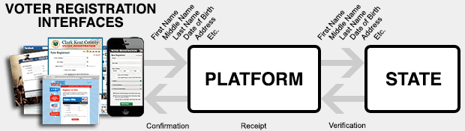
To learn more about this program visit the Rock the Vote website http://www.rockthevote.com/partner/.

IV. Sample Outreach Documents
a. Sample Email to Community Members

Emails to your community should be short and to the point. Make sure you have a descriptive subject line and that you highlight the link to the online voter registration page by bolding it or making it another color. You may also consider sending out a few reminder emails to follow up on your initial email as the voter registration deadline approaches.

Subject Line: Complete your voter registration form Online!

Dear [Insert Name],

Online voter registration is fast and easy! You can use the online form to register to vote for the first time or even update your voter registration record. Additionally, Online Voter Registration is available in 10 languages: English, Spanish, Chinese, Hindi, Japanese, Khmer, Korean, Tagalog, Thai, and Vietnamese

Register to vote by clicking here

Remind your friends to register to vote by October 20 by sharing the link on social media or forwarding this email.

Election Day is Tuesday, November 4 and you must be registered to vote by October 20, 2014 to participate in this election. You don’t want to miss out on casting your vote to decide the next group of leaders who will represent your local community in Sacramento and Washington DC.

Go online and register to vote today!

Thanks,

Your name
Organization

- Sample Outreach Documents
- Newsletter Article

A newsletter article provides an opportunity to inform your community about online voter registration and the efforts you are making to promote COVR.

Participating in California’s democracy just got easier!

Did you know that you can complete and submit your voter registration form online? Forget the stamps and the trip to the post office. It is easier than ever to register to vote for the first time or update your voter registration record from the comfort of your home using a personal computer, smartphone or tablet.

California Online Voter Registration was launched in English and Spanish in the Fall of 2012 and was updated and translated this Spring into eight additional languages, including: Chinese, Hindi, Japanese, Khmer, Korean, Tagalog, Thai, and Vietnamese.

[INSERT NAME OF ORGANIZATION] has joined efforts with the Future of California Elections and partners to spread the word that Online Voter Registration is ready and available for Californians to use today.
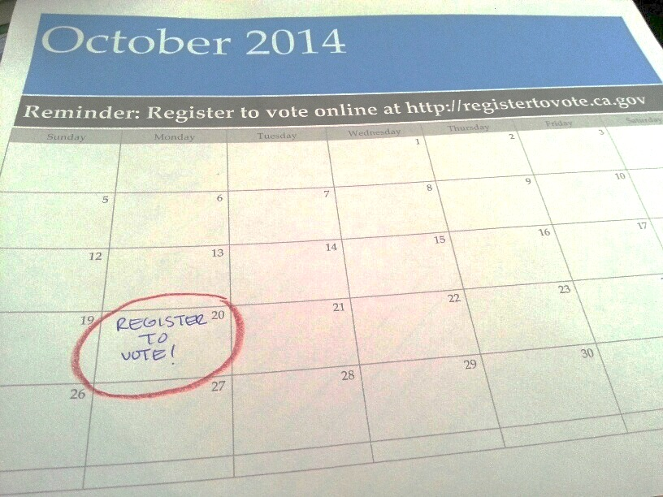
You can access online voter registration here http://registertovote.ca.gov

The voter registration deadline is Monday, October 20, 2014. There are 6 million Californians that are eligible but unregistered to vote. Let’s get all eligible Californian’s registered to vote.

Do you know someone that is eligible but not registered to vote? You can use your cell phone or tablet to help a family member or friend register to vote today. Just visit the Secretary of State’s online voter registration form http://registertovote.ca.gov

Help spread the word by posting the link on social media or forwarding this email to friends and family.

IV. Sample Documents
- Social Media Messages and Image

Twitter

- No time to mail in your voter registration form? No problem! Complete and Submit online http://registertovote.ca.gov/

- It's a great day in #California! Online voter registration is available in 10 languages. Go to http://registertovote.ca.gov/

- #California's online voter registration tool is available in 10 languages so even your abuela can register! http://registertovote.ca.gov/

- Monday, Oct 20 is the last day to register to vote #Election2014 Quick! Register online at http://registertovote.ca.gov/

Facebook

- You don’t have any stamps? That’s ok! Californians can now use online voter registration in 10 languages! Go to http://registertovote.ca.gov/ and register before the deadline on Oct 20

- California is paving the way once again. Voter registration is available online NOW in TEN different languages! Go to http://registertovote.ca.gov/ to register today!

You can also share the following image on Facebook, Twitter or use it as a poster.

- Sample Documents
- Press Release
This press release is also available in Spanish, Chinese, Hindi, Japanese, Khmer, Korean, Tagalog and Thai on our website at http://www.futureofcaelections.org/covr/

[Insert Organization Logo]

FOR IMMEDIATE RELEASE
DATE

Online Voter Registration is Available in 10 Languages
Chinese, Hindi, Japanese, Khmer, Korean, Tagalog, Thai, Vietnamese Added to State Voter Registration Website

Contact: Name, Title, Phone Number

SACRAMENTO – California’s online voter registration website – launched in English and Spanish in 2012 – is now expanded to include eight additional languages: Chinese, Hindi, Japanese, Khmer, Korean, Tagalog, Thai, and Vietnamese. Individuals can now register to vote by visiting http://registertovote.ca.gov and filling out an online form that is available in these languages.

Online voter registration offers a convenient alternative to filling out a registration form at the local DMV office or downloading a form, filling it out, and putting it in the mail. Before the November 2012 election, over half a million people used the online voter registration website to register as new voters.

Advocates expect the translation of online voter registration into multiple languages will help increase registration among Asian Americans and Latinos in California who tend to have relatively low voter registration rates. While 72 percent of non-Hispanic whites and 69 percent of African Americans in California reported being registered to vote in 2012, only 58 percent of Asians and 57 percent of Latinos were registered.

“[Insert Quote, See suggestions on Page 2],” said [First & Last Name] of the [Organization].

The online voter registration website also has a much-improved mobile interface, allowing smartphone and tablet users to register online easily.

Californians will need to register by Monday, October 20 if they wish to vote in the November 4 election. Individuals who are already registered voters do not need to re-register, unless they wish to update their address or change their political party affiliation.

###
Insert NAME OF ORGANIZATION
Insert your organization’s website here

Suggested Topics for Community Organization Quotes in Sample Press Release:

  - “We urge all stakeholders in our community, including media, businesses, faith institutions, and cultural associations, to spread the word about online voter registration. We have changed our website to include a link to the online voter registration website and we hope others will do the same.”

  - “There are over 6 million Californians who are eligible to vote, but not registered. Online voter registration can help change that, but only if everyone in our community helps publicize the website.

  - “___ percent of __________ have limited proficiency in English. Translated online voter registration has significant potential to reduce voter registration barriers faced by those in our community.”

Data for Community Organization Quotes:
The following are limited English proficiency rates for various population groups (statewide figures for population five years and older):
- Cambodian Americans, 44%
- Chinese Americans (not including Taiwanese), 43%
- Filipino Americans, 19%
- Indian Americans, 23%
- Japanese Americans, 18%
- Korean Americans, 48%
- Latinos, 38%
- Taiwanese Americans, 47%
- Thai Americans, 41%
Vietnamese Americans, 52%

Office of the California Secretary of State 60-day close of registration report for the June 2014 election, available at http://www.sos.ca.gov/elections/ror/ror-pages/60day-primary-2014/hist-reg-stats.pdf
U.S. Census Bureau, Current Population Survey, November 2012

