08
Fall

September 2015

Community Outreach Toolkit: California Online Voter Registration

The Community Outreach Toolkit provides practical tools to support organizations promoting use of online voter registration in their communities.

California Online Voter Registration (COVR) allows eligible voters to complete and submit their voter registration online. It is available in 10 languages: English, Spanish, Chinese, Hindi, Japanese, Khmer, Korean, Tagalog, Thai, and Vietnamese.

This Toolkit is made possible through the collaboration of the
Future of California Election Members

www.futureofcaelections.org

TABLE OF CONTENTS
- Why promote voter registration: The Voter Registration Gap in California 2
- Frequently Asked Questions 3
- Strategies for promoting online voter registration in your community 6
- Adding the COVR link button to your website 7
- Sample Outreach Documents 10
Section A. Outreach Email
Section B. Newsletter Article
Section C. Social Media Messages and Image
Section D. Press Release

- Why promote voter Registration: The Voter Registration Gap in California

Why does California need a Voter Registration Community Outreach Toolkit?

There are millions of Californians who are eligible to vote but are not registered and the disparities are greatest among youth and communities of color.

- Younger populations have the largest gap between those who are eligible to register to vote and those who are actually registered and vote.

Source: U.S. Census Bureau, Current Population Survey, November 2014

- People of color have large gaps between those that are eligible to register to vote and those are actually registered and vote.

Source: U.S. Census Bureau, Current Population Survey, November 2014

Spreading the word about California’s online voter registration system can help turn these low voter registration numbers around.

Registering is easier than ever. You can complete and submit your voter registration form online and it’s available in 10 languages: English, Spanish, Chinese, Hindi, Japanese, Khmer, Korean, Tagalog, Thai, and Vietnamese.
- Frequently Asked Questions About Voter Registration
(Adapted from the California Secretary of State FAQ http://www.sos.ca.gov/elections/frequently-asked-questions/)

- Who is eligible to register to vote?
To register to vote in California, you must be:
- A United States citizen
- A resident of California
- 18 years of age or older on Election Day
- Not currently imprisoned or on parole for the conviction of a felony
- Determined to be able to, with or without reasonable accommodations, communicate their desire to vote

- How and where do I register to vote?
To register to vote you must complete a voter registration application on paper or online.

On paper:
Pick up a paper application at the DMV, post offices, public libraries, and government offices. To have a paper application mailed to you contact the Secretary of State's toll-free voter hotline at (800) 345-VOTE or your county elections office. To look up your county elections office visit http://www.sos.ca.gov/elections/voting-resources/new-voters/county-elections-offices/.

Online:
Go to the Secretary of State’s voter registration website to complete and submit the application online: http://registertovote.ca.gov/.

- What is online voter registration?
Online voter registration replaces the paper application and allows you to complete and submit your voter registration online.

The system will search the Department of Motor Vehicles (DMV) database for your California driver license or identification card number, date of birth, and last four digits of your social security number. If your information is found and you authorize elections officials' use of your DMV signature, an electronic image of your DMV signature will be added to your voter registration application after you click "submit" at the end of the online application.

If there is no signature on file with the DMV because you have never been to the DMV to get a driver’s license or California state identification card, you can still complete the form. Please see the next question for additional detail.

- Do I need state-issued identification to register to vote online?
No. If you do not have a driver’s license or a state identification card, you can still register to vote online. You will have to check a box indicating that you do not have identification. At the end of your application, you will be given an opportunity to print out your application. You can print it, sign it, and mail it to your county elections office. If you do not have a printer or postage, you can still submit your application electronically. Your county elections office will receive the information and send a mailer to the address at which you registered to vote to request your signature and finalize your application. Find that mailer, sign it as instructed, and mail it back.

Is online voter registration related to online voting?
No. Online voting does not exist in California. For security reasons, California law prohibits casting a ballot over the Internet. This also means that county elections officials cannot accept marked ballots sent via email from military and overseas voters. For more information on military and overseas voters visit http://www.sos.ca.gov/elections/voter-registration/military-overseas-voters/.
- Are voter registration applications available in languages other than English?
The California Secretary of State's online application is available in English, Spanish, Chinese, Hindi, Japanese, Khmer, Korean, Tagalog, Thai, and Vietnamese.
To request a paper application in the above languages contact the Secretary of State's toll-free voter hotline at (800) 345-VOTE.

Am I already registered to vote?
To find out if you are currently registered to vote, go to the Secretary of State's Check Status of Your Voter Registration web page at http://www.sos.ca.gov/elections/registration-status/.
- I was previously incarcerated. Can I register to vote?
You are eligible to register and vote if you are:
- In county jail serving a misdemeanor sentence. A misdemeanor never affects your right to vote.
- In county jail because jail time is a condition of probation
- On probation
- On mandatory supervision
- On post-release community supervision
- Done with parole. Your right to vote is automatically restored when you complete your parole. You just need to fill out a voter registration application either online or using a paper registration card.

You are not eligible to register and vote if you are:
- Currently imprisoned
- In state prison
- In county jail serving a state prison sentence
- Currently on parole

For more information on the rights of people who have been incarcerated, please see the Secretary of State's Voting Rights for Californians with Criminal Convictions or Detained in Jail or Prison http://www.sos.ca.gov/elections/voting-resources/new-voters/who-can-vote-california/voting-rights-californians or the ACLU of San Diego’s information page https://www.letmevoteca.org/.
- When and how do I update my voter registration?
You must update your voter registration and re-register when you:
- Move to a new permanent residence
- Change your name
- Change your political party preference

You can re-register by completing the voter registration application. See question 2 above.

Note: If you have changed your name and you have not yet updated your legal name with the DMV, select "decline" on the application when asked to use your DMV signature to register to vote. If you do not decline, you DMV signature will not match the name with which you are registering to vote.

After you decline to use your DMV signature, continue filling in your information and click "print" at the end of the online application. Sign the paper application and mail it to your county elections office. If you do not have a printer, don’t worry. The county elections office will receive your information and send a mailer to the address at which you registered to vote to request your signature and finalize your application. Find that mailer, sign it, and mail it back.

The California Secretary of State recommends that you update your DMV record as soon as you change your legal name. To contact the DMV visit http://www.dmv.ca.gov/portal/dmv/detail/contacts/contacts.

10. What is the voter registration deadline?
In California, the deadline to register to vote for any election is 15 days before Election Day. To find dates for local elections contact your county office: http://www.sos.ca.gov/elections/voting-resources/new-voters/county-elections-offices/.

III. Strategies for Promoting Online Voter Registration in Your Community

Use the following list of strategies to promote online voter registration in your community. The best approach is to implement two or three strategies simultaneously to build momentum.

- Website
Place a link to online voter registration link to your website homepage or within three clicks of your home page. See the many organizations promoting online voter registration and join our Wall of Fame at http://futureofcaelections.org/ovr-wall-of-fame/.

- Email Blast
Send an email to your respective networks to let people know they can use the online voter registration website and that it is available in 10 languages.

- Flyer/Pamphlet
Share a flyer and/or pamphlet with the link to the online voter registration website at your organization’s meetings and any upcoming events. Post the flyer in high traffic areas in your community.

- Phone banking and Door knocking – Voter Contact
Add online voter registration to your organization’s Get out the Vote (GOTV) efforts:
- Let voters know they can easily update their registration status through the online voter registration website (e.g. changing their address, name, party preference, or language preference, or signing up for permanent vote by mail)
- Ask voters to let eligible but unregistered members of their household know about online voter registration and its availability in 10 languages.

- Newsletter
Announce the online voter registration website in your organization’s existing newsletter.

- Social Media
Utilize Facebook, Twitter, LinkedIn, etc. to promote and connect people to the multilingual online voter registration tool.

- Ethnic Media
Reach out to ethnic media outlets in order to educate and promote the use of online voter registration website in multiple languages.

- Invite local community institutions to join this effort
Ask businesses, faith institutions, cultural clubs, language schools, and other local entities to include an online voter registration link on their websites. Share this toolkit with them.

Section IV. Adding Voter Registration to your Website

We encourage you to put a button on your website that links people to online voter registration. The best place to locate the button is on your homepage or within three clicks of your homepage.

Place the link on the website pages that people are most likely to visit.

THERE ARE TWO OPTIONS FOR ADDING A BUTTON TO YOUR WEBSITE

OPTION 1: Link to Online Voter Registration via the Secretary of State Web Button
The Register to Vote Button allows people to link directly from your website to the California Secretary of State Online Voter Registration, available at http://registertovote.ca.gov.

The Register to Vote Button is available in 10 languages: English, Spanish, Chinese, Hindi, Japanese, Khmer, Korean, Tagalog, Thai, and Vietnamese.

For the sample code to add these languages to your website visit the Secretary of State’s website: http://www.sos.ca.gov/elections/register-vote-buttons/.

EXAMPLE:
Copy and paste the sample code to your web page.
Sample Code:
<a href="http://registertovote.ca.gov/"><img src="http://cms.cdn.sos.ca.gov/img/rtv/rtv-en.jpg" alt="Secretary of State - Register to Vote" width="130" height="55" />/a>

OPTION 2: Link to Online Voter Registration via a third party partnership with Rock the Vote
Rock the Vote partners with organizations to provide technical support and voter engagement through its integrated online voter registration tool.

Rock the Vote partners with organizations to customize the voter registration tool to match the style of the host website. This provides the added benefit of allowing people to register to vote and opt-in to the partner’s voter education and mobilization programming – including registration deadline reminders, Election Day reminders, ballot information, volunteer opportunities, and more. Rock the Vote provides partners with up-to-date information about the individuals who are using the co-branded tool to register, including the number of registrants, and a breakdown by age and gender. The Rock the Vote tool is integrated with the California Secretary of State online voter registration to allow for a seamless and secure online user experience.
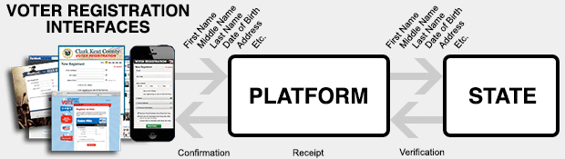
To learn more about this program visit the Rock the Vote website at http://www.rockthevote.com/partner/.

ONLINE VOTER REGISTRATION WALL OF FAME
Future of California Elections recognizes organizations which demonstrate best practices for promoting online voter registration on the OVR Wall of Fame: http://futureofcaelections.org/ovr-wall-of-fame/.
To be listed on the Wall of Fame please email sjimenez@futureofcaelections.org.

CASE STUDY: CALPIRG, a member of the Future of California Elections, supports colleges and universities as they develop and institutionalize new ways to offer voter registration opportunities to their campus communities. CALPIRG encourages campuses to post a button linking to online voter registration on the following pages: email login page, class registration portal, University homepage, Blackboard (which many campuses use to connect students to class material online), Athletics page, Libraries main page, campus calendar, or student activities webpage.

CASE STUDY: The NALEO Educational Fund, a member of the Future of California Elections, works with cities across the state to encourage OVR placement into sections of their websites that community members access frequently. The goal of this effort is to make OVR more accessible to those who visit public websites for other online information and services, such as utilities payment and upcoming events. The NALEO Educational Fund works with local entities to help determine the best incorporation of OVR that meets their individual needs, as well as providing information on innovative website technology and systems that make voter registration more efficient.
V. Sample Outreach Documents - Section A. Sample Email to Community Members

Emails should be short and to the point, include a descriptive subject line and highlight the link to the online voter registration page. Send out at least one follow up email as a reminder.

Subject Line: Did you Move? Recently turn 18? Are a new U.S. Citizen?

Dear [Insert Name],
Did you Move? Recently turn 18? Are you a new U.S. Citizen?

If you answered yes, then register to vote for the first time or update your voter registration. In California you can complete and submit your voter registration form online – It’s fast and easy!

Online Voter Registration is available in 10 languages: English, Spanish, Chinese, Hindi, Japanese, Khmer, Korean, Tagalog, Thai, and Vietnamese

Register to vote by clicking here http://registertovote.ca.gov

Not sure if you are registered to vote?
Check here http://www.sos.ca.gov/elections/registration-status/
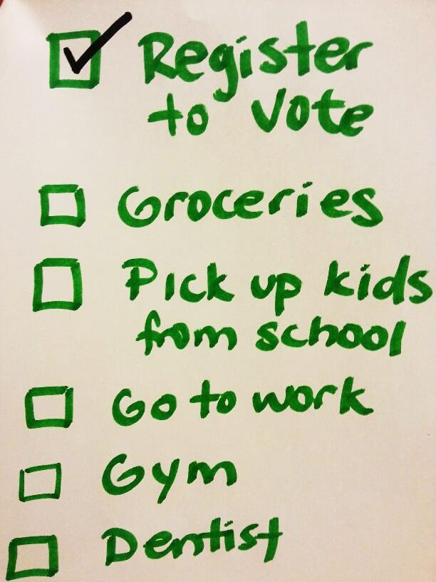
Don’t wait until the last minute to register to vote.
Check this off your To Do list and Register today!

Thanks,

Your name
Organization

P.S. Let’s get our friends registered to vote. Forward this email to 5 people.

  - Sample Outreach Documents – Section B. Newsletter Article

A newsletter article provides an opportunity to inform your community about online voter registration and the efforts you are making to promote COVR.

Participating in California’s democracy just got easier!

Did you know that you can complete and submit your voter registration form online?

[INSERT NAME OF ORGANIZATION] has joined efforts with the Future of California Elections and partners to spread the word that Online Voter Registration is available for Californians to use today.

You can access online voter registration here http://registertovote.ca.gov.

Forget the stamps and the trip to the post office. It is easier than ever to register to vote for the first time or update your voter registration record from the comfort of your home using a personal computer, smartphone or tablet.

California Online Voter Registration is available in 10 languages including: English, Spanish, Chinese, Hindi, Japanese, Khmer, Korean, Tagalog, Thai, and Vietnamese.

There are 6 million Californians that are eligible but unregistered to vote. Let’s change that number. Do you know someone that is eligible but not registered to vote? Use your cell phone or tablet to them register to vote today.

Help spread the word by posting the voter registration link on social media and forwarding this email to friends and family.

V. Sample Documents – Section C. Social Media Messages and Image

Popular Hashtags & Their Meaning
#NVRD = National Voter Registration Day
#Election2016 = November 2016 Presidential Election

Twitter

- It’s time for #NVRD Join thousands nationwide and update your voter registration or register for the first time http://registertovote.ca.gov/

- It’s never too early to get ready for #Election2016. Register to vote or Update your voter registration online http://registertovote.ca.gov/

- No time to mail in your voter registration form? No problem! Complete and Submit online http://registertovote.ca.gov/

- It's a great day in California! Online voter registration is available in 10 languages. Go to http://registertovote.ca.gov/

- California's online voter registration tool is available in 10 languages so even your abuela can register! http://registertovote.ca.gov/

- Moved Recently? Update your voter registration online at http://registertovote.ca.gov/

Facebook

- You don’t have any stamps? That’s ok! Californians can now use online voter registration in 10 languages! Go to http://registertovote.ca.gov/ and register today!

- California is paving the way once again. Voter registration is available online NOW in TEN different languages! Go to http://registertovote.ca.gov/ to register today!
Share the image on Facebook, Twitter or Instagram, or use it as a poster.

- Sample Documents – Section E. Press Release

[Insert Organization Logo]

FOR IMMEDIATE RELEASE
DATE

Online Voter Registration is Available in 10 Languages: English, Spanish, Chinese, Hindi, Japanese, Khmer, Korean, Tagalog, Thai, and Vietnamese

Contact: Name, Title, Phone Number

SACRAMENTO – California’s online voter registration is available in 10 languages: English, Spanish Chinese, Hindi, Japanese, Khmer, Korean, Tagalog, Thai, and Vietnamese. Individuals can register to vote by visiting http://registertovote.ca.gov and filling out and submitting an online form that is available in these languages.

Online voter registration offers a convenient alternative to filling out a registration form at the local DMV office or downloading a form, filling it out, and putting it in the mail.

Advocates expect the availability of online voter registration in 10 languages will help increase registration among Asian Americans and Latinos in California, populations that tend to have relatively low voter registration rates.

“[Insert Quote, See suggestions below] said [First & Last Name] of the [Organization].

The online voter registration website also has a much-improved mobile interface, allowing smartphone and tablet users to register online easily.

The online voter registration system may also be used to update your address or political party affiliation.

###
Insert NAME OF ORGANIZATION
Insert your organization’s website here

Suggested Topics for Community Organization Quotes in Sample Press Release:

  - “We urge all stakeholders in our community, including media, businesses, faith institutions, and cultural associations, to spread the word about online voter registration. We have changed our website to include a link to the online voter registration website and we hope others will do the same.”

  - “There are over 6 million Californians who are eligible to vote, but not registered. Online voter registration can help change that, but only if everyone in our community helps publicize the website.

