Prepared for the 2020 Presidential Primary Election

Same Day Voter Registration
Toolkit for Elections Officials

Last updated December 2019

Introduction
Same Day Voter Registration (Same Day VR), or conditional voter registration, has the potential to streamline election administration and to improve the voter experience. Initially, the election administration practice was limited to elections offices or other designated locations. In 2016, the Voter’s Choice Act (VCA) expanded Same Day VR to any vote center in the VCA county. In 2019, with the passage of SB 72, Same Day VR is now available at every polling place in California, starting in the 2020 Presidential Primary Election.
The Same Day Voter Registration Toolkit for Election Officials provides plain language text and sample materials to support smooth implementation of the new law. This toolkit was prepared in collaboration with the ACLU of California, Asian Americans Advancing Justice-Asian Law Caucus, Center for Civic Design, League of Women Voters of California, Santa Barbara Registrar of Voters, and Santa Cruz County Registrar of Voters.
Founded in 2011, Future of California Elections (FoCE) is a nonpartisan network of election officials, reform, civil rights and civic engagement groups working in collaboration to modernize elections and expand participation in California.

Table of Contents
Introduction 2
Part 1. Sample Language for Voter Education Materials 3
Part 2. Sample Envelope & Registration Form for CVR 6
Part 3. Sample Social Media Graphics 7
Part 4. Sample Frequently Asked Questions 9
Part 5. A voter decision chart (Non-VCA counties) 5
Part 6. Instructions for Poll Workers (Non-VCA counties) 6
Part 7. Sample Language for Official No Party Preference Ballot 7

Part 1. Sample Language for Voter Education Materials
Use the following language Before the Voter Registration Deadline:
Want to vote in the 2020 Presidential Primary Election?
Yes, but I am not registered to vote
Register to vote online. It’s easy and quick. Registertovote.ca.gov
Contact your elections office to request a paper registration form.

Yes, but I’m not sure if I am registered
Check your voter registration status at voterstatus.sos.ca.gov or call (800) 345-VOTE (8683)

Yes, I’m registered. But, what else can I do to get ready?
Double check your party registration status at voterstatus.sos.ca.gov or call
(800) 345-VOTE (8683). Political party matters for the presidential primary election. Learn more at www.sos.ca.gov/elections/voting-info/how-vote-president

Use the following language After the Voter Registration Deadline:
Registering to Vote After February 18?
You may register to vote all the way up to Election Day, at your voting place or online at Registertovote.ca.gov. You will still be able to vote and your ballot will count once your elections office verifies your registration. This is called Same Day Voter Registration.
Register to vote online at Registertovote.ca.gov. After February 18, 2020 you may also be able to register and vote on the same day at a designated location or your voting place. It’s three simple steps you can complete in one visit:
- You register to vote
- You vote
- You seal your ballot in a special envelope and sign the envelope
Political party matters for the presidential primary election. Learn more at www.sos.ca.gov/elections/voting-info/how-vote-president
Use the following language to explain voter registration for the Presidential Primary Election. The green sections are language for VCA counties, remove as needed.
Political party matters for the Presidential Primary Election.
Voting by mail?
The last day to request a vote by mail ballot from your elections office is February 25, 2020. You reside in a Voter’s Choice Act (VCA) county and will automatically receive a ballot in the mail.
If you are registered with a political party, you will receive a ballot with the candidates running for President for that party.
If you are not registered with a political party, you will be mailed a nonpartisan ballot, which will not list presidential candidates, unless you contact your elections office to request a partisan ballot.
The Democratic Party, American Independent Party and Libertarian Party allow voters who are not registered with a political party to vote their party’s ballot. Requesting one of these party ballots for the presidential primary, does not change your voter registration.

The Green Party, Peace and Freedom Party and Republican Party allow only voters registered with their party to vote in their presidential primary. To vote for these parties, you need to change your voter registration. You can always re-register again after the election as either a “No Party Preference” voter or with any political party. Register or re-register online at Registertovote.ca.gov by February 18, 2020 to save time and avoid the lines. You may still register after February 18 at your voting place or designated location up to and including Election Day, March 3, 2020.

Voting In-person?
If you are registered with a political party, you will be handed a ballot with the candidates running for President for that party once you arrive at your voting place.
If you are not registered with a political party, you will arrive at your voting place and select a ballot from the following choices: Nonpartisan ballot (will not list presidential candidates), a Democratic Party ballot, American Independent Party ballot or a Libertarian Party ballot.
You need to change your voter registration to vote for the Green Party, Peace & Freedom Party, or Republican Party candidates. You can always re-register again after the election as either a “No Party Preference” voter or with any political party.

Use the following language to encourage registration by February 18:
Reminder: Register to vote by February 18 to take advantage of all the services offered by your elections office. Avoid the lines, register early. It's easy and quick.

- If you register by February 3, 2020, you receive your state and county voter guides in the mail with all the information you need to vote.
- If you register by February 18, 2020, your name is on the voter list at your voting site and you still have time to request a vote by mail and request materials in other languages.

Contact your elections office for more information
INSERT PHONE NUMBER INSERT EMAIL INSERT WEBSITE

Part 2. Sample Envelope & Registration Form for CVR
A best practice for Same Day Voter Registration is to integrate the voter registration form directly onto the Same Day Voter Registration ballot envelope. This will help streamline the process and reduce paper.

Click the links below for a sample Same Day VR Envelope and Registration Form.

- Word Version
- PDF Version

Please note this 8.5 x 11 sample envelope does not include registration history as required by the Elections Code. This sample is to be used just as a starting point.

Election officials should ensure their final documents comply with all election code requirements.

Thank you to Gail Pellerin, Santa Cruz County Registrar of Voters, for developing and sharing this resource.

Part 3. Sample Social Media Graphics
A best practice for social media is to use an image or graphic to attract the attention of your audience. Below are a few sample images.

You can save these on your computer as a .png by hitting right click on the image and selecting “save as picture.” This will download in the local folder you select. You can then use this image later by uploading the picture on your social media.

To customize the graphics you need a free Canva account. Contact hello@futureofcaelections.org for the customizable templates.

This size is optimized for Instagram:

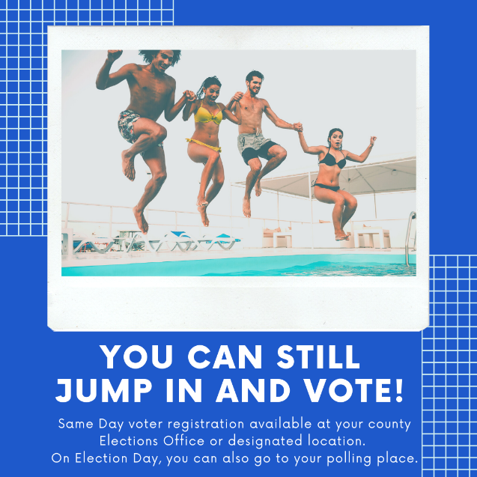
Click here to download Click here to download

This size is optimized for Twitter:
Click here to download
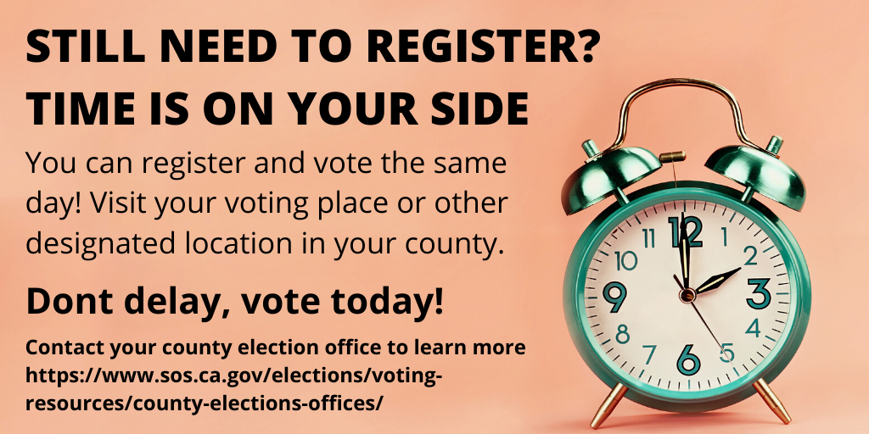
Click here to download

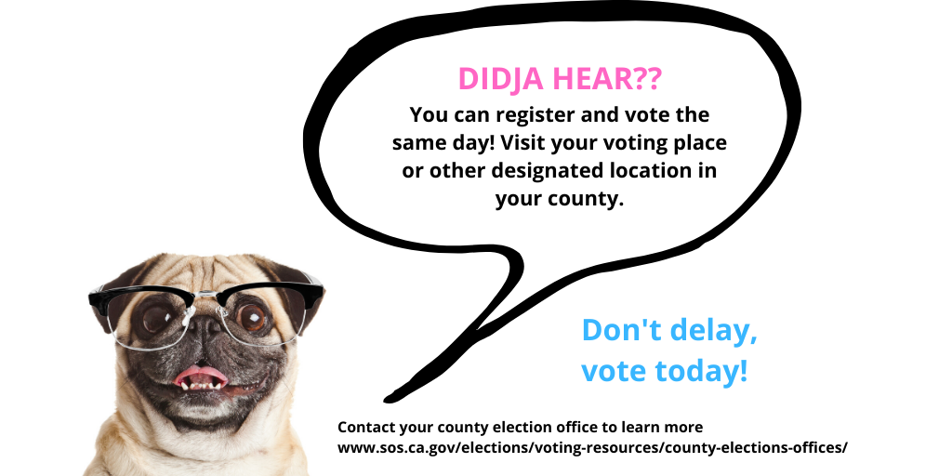
Click here to download

Part 4. Sample Frequently Asked Questions
The following is a sample document for frequently asked questions. Customize the yellow sections by adding your elections’ office information. The green sections are language for VCA counties, remove as needed.

The following information is listed only for an example. To learn about Santa Cruz County elections, visit votescount.com.

Missed the voter registration deadline?
You can still register and vote on the same day!

Go to one of the following locations today:

Santa Cruz County Elections Office
701 Ocean St., Room 310
Monday – Friday, 8am to 5pm
Sat & Sun, Feb. 29 & March 1, 9am to 5pm
Tuesday, March 3 , 7am to 8pm
Watsonville City Clerk’s Office
275 Main St.
Monday – Friday, 8am to 5pm
Go to Community Room Sat & Sun
Sat & Sun, Feb. 29 & March 1, 9am to 5pm
Tuesday, March 3 , 7am to 8pm

Or the following locations starting February 29:
UCSC Bay Tree Conference Center
Quarry Plaza
Sat & Sun, Feb. 29 & March 1, 9am to 5pm
Monday, March 2, 8am to 5pm
Tuesday, March 3, 7am to 8pm

Live Oak Sheriff’s Service Center
5200 Soquel Ave, Santa Cruz, CA 95062
Sat & Sun, Feb. 29 & March 1, 9am to 5pm
Monday, March 2, 8am to 5pm
Tuesday, March 3, 7am to 8pm

Simpkins Family Swim Center
979 17th Ave, Santa Cruz, CA 95062
Sat & Sun, Feb. 29 & March 1, 9am to 5pm
Monday, March 2, 8am to 5pm
Tuesday, March 3, 7am to 8pm

Community Foundation
7807 Soquel Dr, Aptos, CA 95003
Sat & Sun, Feb. 29 & March 1, 9am to 5pm
Monday, March 2, 8am to 5pm
Tuesday, March 3, 7am to 8pm 3

All Polling Places in Santa Cruz County Open 7am to 8pm, Tuesday, March 3

Do you still need to register to vote?

You can register and vote on the same day. Visit your elections office or designated location. Visit any voting place in your county starting 10 days before Election Day and through Election Day.

It’s three simple steps you can complete in one visit:
- You register to vote
- You vote
- You seal your ballot in a special envelope and sign the envelope

Your vote will be counted after elections officials verify your voter registration and confirm you have not already voted in this election. You can check if your ballot was counted and, if not, why not. After the election, visit www.votescount.com or call 831-454-2060 to check the status of your ballot.

This process is called Same Day Voter Registration.

Save time, avoid the lines, register by February 18, 2020

Frequently Asked Questions

What is the voter registration deadline?
The 15-day deadline for the March 3, 2020 is February 18, 2020. (Since the 15th day before the election is a holiday, the deadline is moved to the next business day.)

Why does the voter registration deadline matter?
There are a lot of milestones as we get close to Election Day. The earlier you register to vote the more you can receive the services offered by your elections office.

If you register 29 days before the election, you receive your state and county voter guide in the mail with all the information you need to vote.

If you register 15 days before the election, your name is on the voter list at your voting site and you still have time to vote by mail.

If you register after the 15th day, but before Election Day, you must go to a county office, or designated location, to register and vote. On Election Day you can visit your polling place to register and vote. Be prepared to wait in line and fill out a form providing your name, residence, political party or no party, etc.

You can register to vote and vote all in one visit at any vote center in your county, starting 10 days before Election Day and through Election Day.

Click here to find your voting place www.sos.ca.gov/elections/polling-place

Where do I check if I am registered to vote?
Visit voterstatus.sos.ca.gov or call 831-454-2060 to look up your registration.

Where should I register and vote after February 18?
You can register to vote and vote all in one visit at any vote center in your county, starting 10 days before Election Day and through Election Day.

After February 18, you must go to a designated location before Election Day. On Election Day you can visit you polling place.

For the March 3, 2020 election, we will offer Same Day Voter Registration at the following locations:
- Santa Cruz County Elections Department – 701 Ocean St., Room 310, Santa Cruz
- Watsonville City Clerk’s Office (moves to the Community Room for Feb. 29 to March 3) – 275 Main Street, 4th Floor, Watsonville
- UCSC Bay Tree Conference Center – Quarry Plaza (Saturday – Tuesday, Feb. 29 to March 3 only)
- All polling places in Santa Cruz County, 7am to 8pm, Tuesday, March 3.

Can I pick up a voter registration form and come back to vote later?
It’s best to do it all at once, but you can also register online at registertovote.ca.gov. Many counties use an envelope for voters registering on the same day that has your voter registration form printed on the front of the envelope.

Will my ballot be counted?
- Your ballot will be counted if:
- Your signature on the ballot envelope matches the one on your voter registration form.
- You provide all the information needed to identify you on your voter registration form -- including your name, home (residence) address, and date of birth.
- This is the only ballot you cast in this election.

Is this voter registration good for the next election, too?
Yes. You are now permanently registered to vote under the name and address on your voter registration form. Remember that you will need to update your registration if you move, change your name, or want to change your political party.

Part 5. A voter decision chart (Non-VCA counties)
Use the following chart to illustrate to a voter what steps they need to make depending on their circumstance.

If you: | You can go to: | How you vote:
Registered to vote before the 15-day deadline (February 18, 2020) | Any early voting location OR Your polling place | Vote a regular ballot
Are not registered to vote | Your county elections office or designated location in advance of Election Day. On Election Day visit your polling place. | Complete a voter registration form  Vote using Same Day VR *
Are registered in another county | Your new county elections office or designated location in advance of Election Day. On Election Day visit your new polling place. | Complete a voter registration form  Vote using Same Day VR *
Have moved within the county where you are registered to vote | Your new county elections office or designated location in advance of Election Day. On Election Day visit your new polling place. | Complete a voter registration form  Vote using Same Day VR *
Vote by mail, but do not have your vote by mail ballot | Your polling place | Vote with a provisional ballot*
Are not near your polling place | Visit any polling place, however, you may not be able to vote your local election. | Vote with a provisional ballot*
Are not found in the voter list, or there are questions about your voter registration | Check your voter registration status at voterstatus.sos.ca.gov or call (800) 345-VOTE (8683) | Vote with a provisional ballot*
*Your vote will be counted after elections officials verify your voter registration and confirm you have not already voted in this election.

Part 6. Instructions for Poll Workers (Non-VCA counties)
Poll workers are the primary resource of information for voters at polling places. Poll workers well trained on Same Day Voter Registration practices will help voters have a successful Election Day.

The following is a sample document for poll worker training materials. Customize the yellow sections by adding your elections’ office information.

The following information is listed only for an example. To learn about Santa Cruz County elections, visit votescount.com.

Click the links below for Sample Instructions for Poll Workers

- Word Version
- PDF Version

Thank you to Gail Pellerin, Santa Cruz County Registrar of Voters, for developing and sharing these resources.

Part 7. Sample Language for Official No Party Preference Ballot
Use the following sample language for the official No Party Preference Ballot. This plain language explanation will let a voter know why they do not have presidential candidates listed in their ballot and what they can do next if they want to vote for president.

Voting for President depends on the party you are registered with.

You are registered as a No Party Preference voter.

Therefore, the contest of President does not appear on this ballot.

If you want to vote for President, contact your elections official to get a party ballot [Insert Phone number, Email, Website]

